LTsocial Guild Report — LT Social Universe (Beta)
Project: LTSocial.net / “LT Social Reality / LT Social Universe”
Scope: Full-site mockup + web app shell + pricing + feed model + safety + creator/crypto layers
Tagline: Mining Miracles Everyday — Connect. Plan. Stream. Earn. Stay Safe.
Prepared: 2026-01-30

1) Executive Summary (What this product is)
LT Social is a “safe social universe” that combines a social app, a streaming hub, a marketplace, an economic layer (mining/rewards), and a safety layer (AI Guardian + family-safe controls + temporary location sharing). A defining idea is that relationships and visibility are tiered, so users can safely share more with trusted circles while still maintaining a public-facing creator presence.
- Social: posts, messaging, connections, creator tools
- Streaming: native streaming + creator economy + Twitch bridge
- Marketplace: digital goods/services + optional token rails
- Economic layer: mining dashboards, rewards, token mechanics
- Safety: AI Guardian Hub, family controls, temporary location sharing + check-ins

2) Whole-Site Mockup: What “the whole site” includes

2.1 Marketing / Investor / Docs Site (Public)
- Landing page (value proposition)
- Features (social, safety, streaming, marketplace, mining)
- Products (LTCare, LT Reality & Cafe, Invest Your Data, etc.)
- Technology (IA Rainbow AI, Shift Coin, Token Mechanics, Wallet Demo)
- Investors (revenue model, strategic research, roadmap, investor relations)
- Pricing (subscription plans)
- Legal/Policies (privacy, terms, safety standards)
- Contact / Community

2.2 Web App (Logged-in Product)
- Home feed (multi-feed tabs)
- Profile
- LTRStream
- LTMarket
- LTMessaging
- Calendar (events + tickets + RSVP + invites + sharing to feeds/chats)
- Location (map + temporary sharing + safety check-ins + event map)
- Connections
- LTMiningNetwork
- IA Rainbow Guardian Hub
- LTCare
- Settings

3) Navigation (App Drawer + Section Map)
- Home
- Profile
- LTRStream
- LTMarket
- LTMessaging
- Calendar (events + tickets + RSVP + invites + sharing to feeds/chats)
- Location (map + temporary sharing + safety check-ins + event map)
- Connections
- LTMiningNetwork
- IA Rainbow Guardian Hub
- LTCare
- Settings
- User Card + Logout
Rule of thumb: the drawer is the module switcher. Content objects can be shared across modules (events into feeds/chats, listings into posts, clips into Creator Rooms).
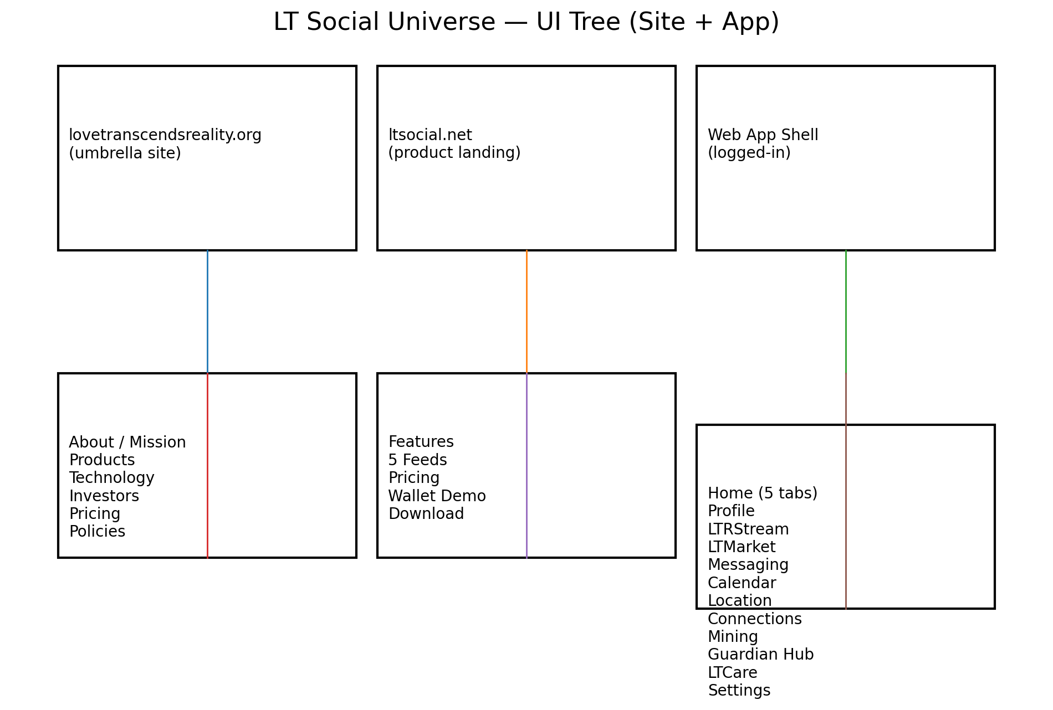
Site + App information architecture
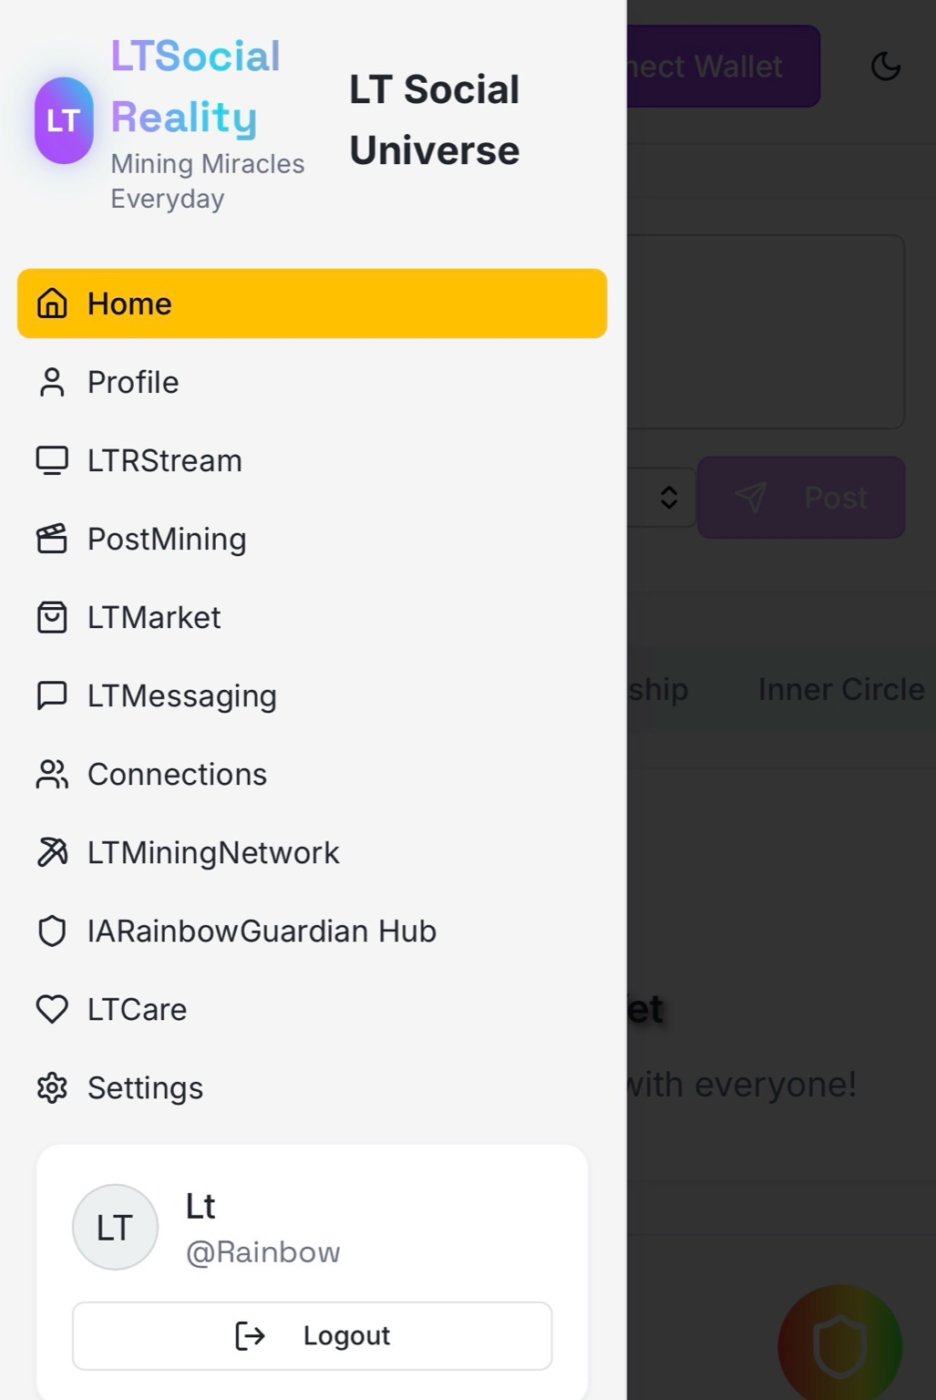
App drawer reference

4) Feed Model Update: from 3 feeds → 5 feeds (Public included)

4.1 The 5 Feeds (Visibility + Intent)
- Public — discovery surface (Explore, hashtags, trending, map/event promos). Safety filtered.
- Fanship — creator/follower relationship layer (free or subscriber-gated).
- Friends — mutual connections; social-first layer.
- Inner Circle — high-trust layer (location share, emergency check-ins, private events).
- Creator Rooms — paid/premium channels for exclusives, replays, drops, PPV streams.

4.2 Posting Rule (How content routes)
Every post selects:
- Feed target (one of the 5 feeds)
- Post type (text/photo/short/long/event/listing/clip/livestream announcement)
- Safety mode (family-safe / mature / restricted)
- Optional monetization toggle (paywall, tip jar, subscriber-only, ticket link)

4.3 Creator Monetization per feed
- Public: tips, affiliate links, sponsored posts
- Fanship: subscriptions + gated posts + replay paywalls
- Friends: private commerce + group events + referral bonuses
- Inner Circle: safety-first features + private meetups + trusted sales
- Creator Rooms: highest ARPU (paid membership + premium drops + PPV streams)

5) Subscription Tiers (Current draft pricing set)

5.1 SelfCelebrity — $50 / month (Most Popular)
- Unlimited connections
- Creator starter tier; monetization + verification workflows
- Split label shown as 30% / 30% (defined in Section 6)

5.2 4Family — $100 / month (Family Safe)
- Family-focused features + parental controls
- Content filtering + household accounts
- Priority support + multi-user management

5.3 Miner — $250 / month
- Enhanced mining capabilities
- Priority blockchain selection
- Higher mining rewards / better rates

5.4 Pearl — $350 / month (Pro tier)
- Pro tier features + VIP support
- Split label shown as 25% / 50% (defined in Section 6)

5.5 Jasper — $500 / month (Elite)
- All features from all plans
- White-glove support; optional white-label (branding/domain/app skin)
- Split label shown as 20% / 40% (defined in Section 6)

5.6 4Family Plus — Price TBA (Coming Soon)
- 1–2x weekly family therapy options (where offered)
- Family wellness tracking + AI Guardian family sessions
- Licensed therapist access (jurisdiction dependent)

5.7 Legacy pricing reconciliation
- If older high-price cards are kept, label them clearly as “Legacy / Enterprise Pilot Pricing”.
- Alternative: move legacy $5,000 tier under “Jasper Enterprise” and keep Miner $250 as standard.
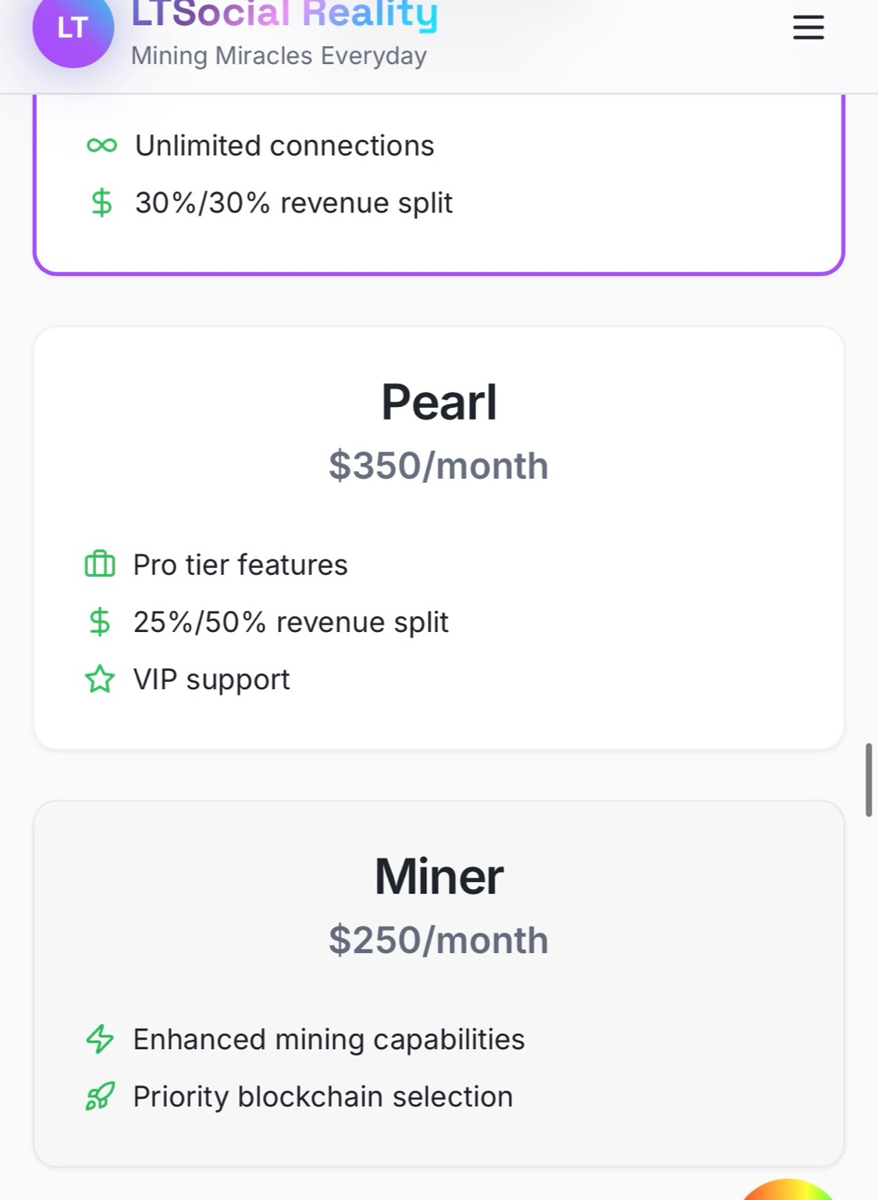
Pricing cards reference (1)
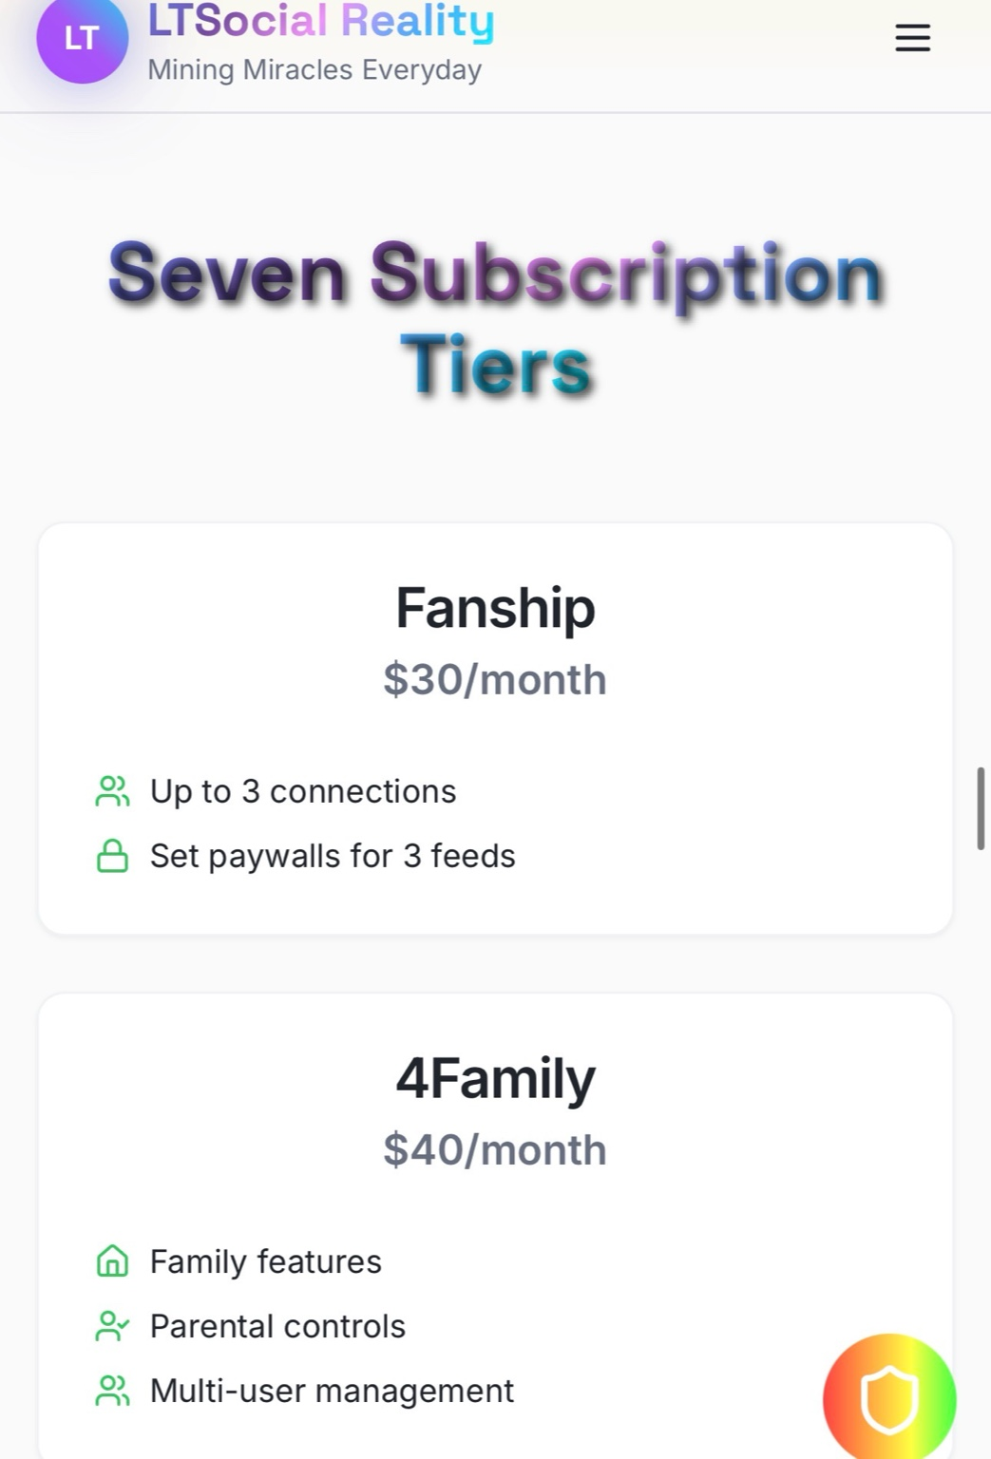
Pricing cards reference (2)
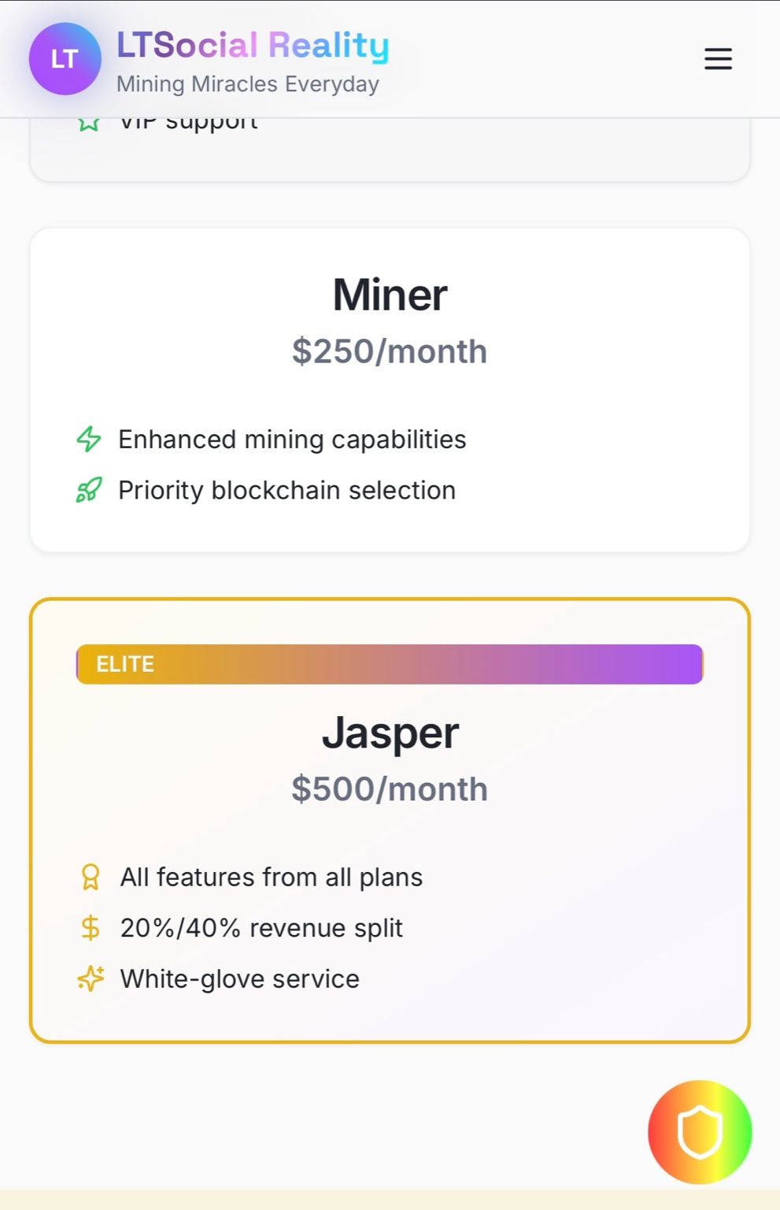
Pricing cards reference (3)

6) Revenue Split Labels (Define the math so it can ship)
To prevent confusion, define split labels consistently across plan cards, checkout, dashboards, and payout screens.
- Creator Share % — what the creator keeps from monetized content
- User Rewards % — redistributed to users (engagement, referrals, community actions)
- Platform % — operations, compliance, infrastructure, safety costs
Example definition format:
- 30/30 = 30% creator share, 30% user rewards, 40% platform
- 25/50 = 25% creator share, 50% user rewards, 25% platform
- 20/40 = 20% creator share, 40% user rewards, 40% platform

7) Core Modules: Product Requirements (Ship list)

7.1 Home (Multi-feed + Explore)
- Top tab bar: Public / Fanship / Friends / Inner Circle / Creator Rooms
- Post composer: media, events, marketplace listing, clip, go live
- Safety defaults: filtering, report/block, comment throttling

7.2 Profile
- Identity + verification state
- Shelves: Posts, Streams, Store, Events, Playlists
- Monetization panel: subscriptions, paywalls, creator rooms, payouts, analytics

7.3 LTRStream
- Go Live native
- Connect Twitch (bridge mode)
- Chat moderation tools
- Replays → save to profile or Creator Rooms with optional paywall

7.4 LTMarket
- Listings: goods/services/digital
- Seller profile + ratings
- Token checkout optional (where compliant)
- Creator storefronts (Jasper/white-label)

7.5 LTMessaging
- Tiered messaging permissions (public DMs limited; fanship DMs allowed; inner circle always allowed)
- Paid DMs optional
- Media messages + safety scans

7.6 Calendar (Events + Tickets + Network Sharing)
- Calendar views: Month / Week / Agenda
- Create & share events: title, time, venue/online, cover, audience (any of 5 feeds/tier rules)
- RSVP & invites: Going/Interested + invite via Connections or Messaging
- Share event cards to feeds and chats
- Event pages: attendees preview, chat thread, directions, optional check-in
- Tickets (phase 2): ticket types, promo codes, in-app checkout, QR entry badges

7.7 Location (Safety + Event Map + Mining Signals)
- Temporary location sharing: 15m / 1h / 4h / Until off
- Circle-based sharing: Friends / Inner Circle / Event attendees / Custom list
- Safety check-ins: scheduled “I’m OK”, location request button, SOS shortcut
- Event map: pins + meet-here markers + optional arrival check-in
- Privacy: off by default, clear indicator, retention + delete controls

7.8 Connections
- Upgrade/downgrade tiers (Fanship ↔ Friends ↔ Inner Circle)
- Tier-based visibility rules + invite restrictions
- Inner Circle enables safety tools

7.9 LTMiningNetwork (Shift Protocol)
- Earnings dashboards
- Device status + boosts
- Chain selection + optimization
- Rewards history export

7.10 IA Rainbow Guardian Hub (AI Guardian)
- User safety status + incident workflow
- Creator moderation rules (filters, keywords, bans)
- Admin tools: anomaly flags, suspicious activity review

7.11 LTCare
- Wellness content
- Family-safe tools integration
- 4Family Plus placeholders (therapy scheduling where offered)

7.12 Settings
- Privacy defaults per feed
- Safety presets + emergency contacts
- Subscription + billing
- Connected accounts (Twitch, calendar)

8) Location (Safety + Sharing + Mining Multipliers) (Inner Circle power feature)
- Temporary sharing presets: 15 min / 1 hr / until ended / custom
- Inner Circle-only default; explicit overrides required
- Stop-sharing always visible
- Audit log (“who could view” + timestamps)
- Check-ins: Arrived / Leaving / Home Safe + route deviation prompts (optional)
- Escalation ladder: ping Inner Circle → emergency contact → optional emergency call
- Mining multipliers (future): opt-in privacy-preserving signals for verified event attendance and community quests

9) Calendar (Events + Tickets + Network Sharing)

9.1 Objects
- Event: title, host, location, time, cover image
- Tickets: tiers, capacity, refund rules
- Safety rating + restrictions (family-safe, 18+, private)
- Category filters

9.2 Flow
Discover → details → buy ticket (card/Apple Pay/Google Pay; token optional) → RSVP → invite → add to calendar → reminders → post-event recap.
- Share event card to feeds + send invites via Messaging/Connections

10) Figma Build Spec (Pages + Frames)

10.1 Figma Pages
- 00 — Cover & Links (overview + clickable sitemap)
- 01 — Design System (colors, type, icons, buttons, cards, spacing)
- 02 — Components (Nav drawer, top tabs, plan cards, modals, forms)
- 03 — Marketing Site (Desktop)
- 04 — Marketing Site (Mobile)
- 05 — Web App Shell
- 06 — Home & Feeds (5-feed tabs)
- 07 — Calendar & Events
- 08 — Pricing & Paywalls
- 09 — Creator Tools
- 10 — Streaming (LTRStream)
- 11 — Marketplace
- 12 — Messaging
- 13 — Location
- 14 — Admin / AI Guardian
- 15 — LTCare

10.2 Core Frame Sizes
- Mobile: 390×844
- Desktop: 1440×900
- Tablet (optional): 834×1194

10.3 Key Frames to draw first (MVP set)
- Marketing: Landing, Features, Pricing, Investors/Roadmap, Technology/Wallet Demo
- Web App: Shell, Home with 5 tabs, Calendar list + detail, Checkout, Live room, Marketplace, Connections tiers, Location share panel

11) Copy / Labels to update in UI (fast checklist)
- Home tabs: Public / Fanship / Friends / Inner Circle / Creator Rooms
- Replace “paywalls for 3 feeds” → “monetize across 5 feeds”
- Pricing cards: SelfCelebrity $50, 4Family $100, Miner $250, Pearl $350, Jasper $500, 4Family Plus TBA
- Plan badges: Most Popular (SelfCelebrity), Family Safe (4Family), Pro (Pearl), Elite (Jasper)

12) Next Implementation Notes (Engineering-ready)
- Store feed selection on every post: visibility_channel = PUBLIC|FANSHIP|FRIENDS|INNER_CIRCLE|CREATOR_ROOM
- Enforce access at API + UI layers
- Centralize revenue split definitions and display labels everywhere
- Create plan entitlements matrix (plan → features → limits)
- Safety-first defaults in posting, messaging, and live chat

Appendix A — Plan Entitlements Matrix (starter)
Feature | SelfCelebrity | 4Family | Miner | Pearl | Jasper
Unlimited connections | ✅ | ✅ | ✅ | ✅ | ✅
Verification badge | ✅ | — | — | ✅ | ✅
Family controls | — | ✅ | — | — | ✅ (add-on)
Mining boosts | — | — | ✅ | ✅ | ✅
VIP support | — | ✅ (priority) | — | ✅ | ✅
White-label | — | — | — | — | ✅
Creator Rooms | ✅ | — | — | ✅ | ✅

Appendix B — Cash-out and conversion policy (site-ready)
- Bank conversion is off-app only: in-app → network wallet → external rails → USD bank → cash.
- During Beta, Reality Coin → USD bank conversion retains 75% to the platform and pays 25% to the user.
- After Beta + official launch, the conversion split becomes 25% platform / 75% user.
- Wallet withdrawals process in two settlement windows daily (morning + night).
- Platform service fees (in-app) may be set up to 95% during Beta until either 250 paying users or the first $1,000,000 gross receipts, then transition to creator-first defaults (commonly 25% platform / 75% earner) where applicable.

Appendix C — Illustrative 10-year financial analysis (base case)
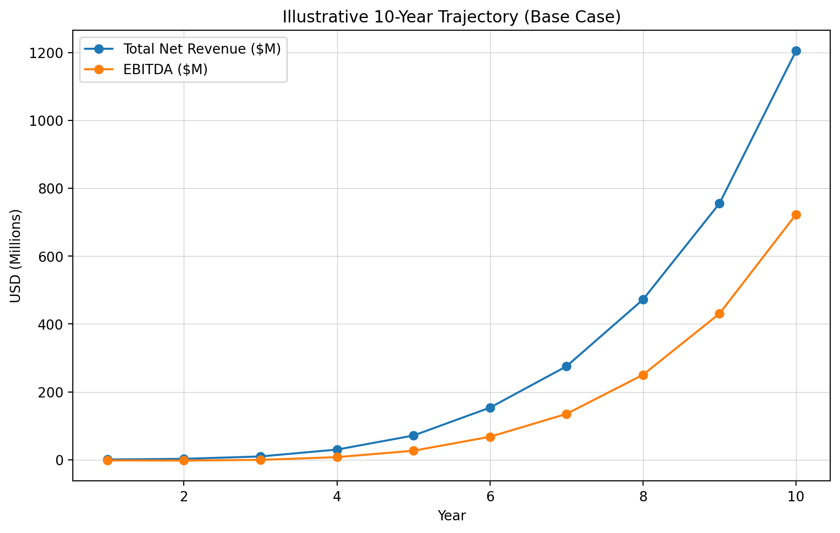
Illustrative net revenue + EBITDA

C.1 Summary (USD millions)
Year | Avg MAU | Paying Users | Total Net Rev ($M) | EBITDA ($M)
1 | 25000 | 250 | 0.41 | -2.20
2 | 100000 | 1500 | 2.46 | -2.66
3 | 300000 | 6000 | 9.44 | -0.63
4 | 750000 | 18750 | 29.70 | 7.42
5 | 1500000 | 45000 | 71.17 | 26.33
6 | 3000000 | 96000 | 153.40 | 67.50
7 | 5000000 | 170000 | 275.29 | 134.89
8 | 8000000 | 288000 | 472.11 | 250.22
9 | 12000000 | 456000 | 755.63 | 430.71
10 | 18000000 | 720000 | 1,205.17 | 723.10

C.2 Full model (USD)
Year | Avg MAU | Paying Users | Subs Gross ($) | Ads Net to Co ($) | Marketplace Rev ($) | Flux Net to Co ($) | Total Net Rev ($) | COGS ($) | OPEX ($) | EBITDA ($)
1 | 25000 | 250 | $351,900 | $33,750 | $4,500 | $22,800 | $412,950 | $115,626 | $2,500,000 | $-2,202,676
2 | 100000 | 1500 | $2,111,400 | $180,000 | $27,000 | $136,800 | $2,455,200 | $613,800 | $4,500,000 | $-2,658,600
3 | 300000 | 6000 | $8,445,600 | $720,000 | $117,000 | $162,000 | $9,444,600 | $2,077,812 | $8,000,000 | $-633,212
4 | 750000 | 18750 | $26,392,500 | $2,362,500 | $405,000 | $540,000 | $29,700,000 | $5,940,000 | $16,335,000 | $7,425,000
5 | 1500000 | 45000 | $63,342,000 | $5,400,000 | $1,080,000 | $1,350,000 | $71,172,000 | $12,810,960 | $32,027,400 | $26,333,640
6 | 3000000 | 96000 | $135,129,600 | $12,150,000 | $2,880,000 | $3,240,000 | $153,399,600 | $24,543,936 | $61,359,840 | $67,495,824
7 | 5000000 | 170000 | $239,292,000 | $23,250,000 | $6,450,000 | $6,300,000 | $275,292,000 | $41,293,800 | $99,105,120 | $134,893,080
8 | 8000000 | 288000 | $405,388,800 | $42,000,000 | $13,200,000 | $11,520,000 | $472,108,800 | $66,095,232 | $155,795,904 | $250,217,664
9 | 12000000 | 456000 | $641,865,600 | $70,200,000 | $24,120,000 | $19,440,000 | $755,625,600 | $98,231,328 | $226,687,680 | $430,706,592
10 | 18000000 | 720000 | $1,013,472,000 | $116,100,000 | $43,200,000 | $32,400,000 | $1,205,172,000 | $144,620,640 | $337,448,160 | $723,103,200

Appendix D — Vision reference
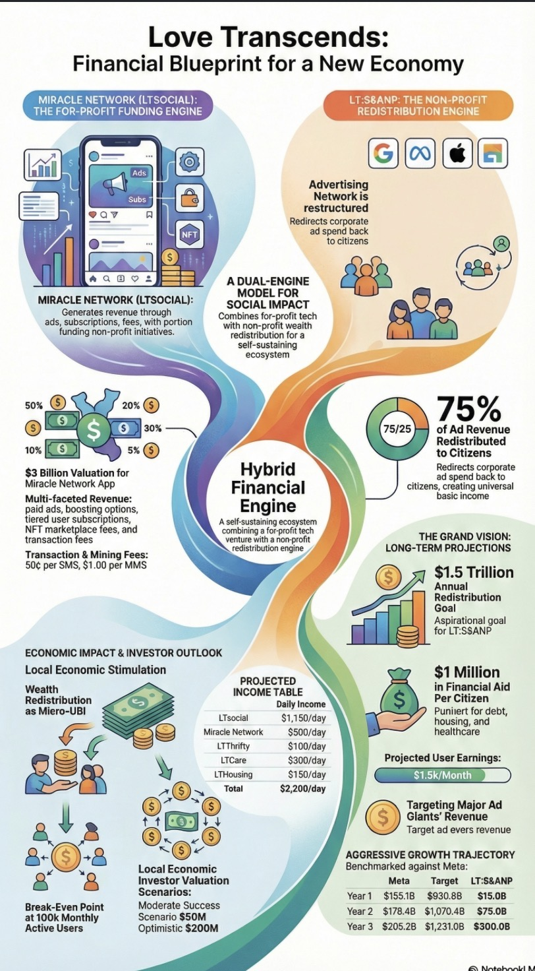
Hybrid financial engine reference diagram

