Investors Guild Report — LT Social Universe (Beta)
LTSocial.net + LoveTranscendsReality.org
(Informational; not an offer to sell securities)
Prepared: 2026-01-30

1) Thesis
LTSocial is a tech-first safe social universe combining tiered feeds, streaming, events, marketplace commerce, and a wallet-enabled settlement layer. The defensible advantage is enforceable policy: access control, payouts, and safety workflows are primitives, not bolt-ons.

2) Product moat (what’s hard to copy)
- 5-feed visibility model (Public → Fanship → Friends → Inner Circle → Creator Rooms) implemented as server-authoritative access control.
- Events as first-class objects (Calendar + Tickets + feed + chat distribution).
- Safety layer: AI Guardian Hub + reporting + escalation + household controls.
- Wallet settlement with transparent ledgers + twice-daily withdrawal windows.

3) Pricing ladder (public beta)
- SelfCelebrity $50 (Most Popular), 4Family $100 (Family Safe), Miner $250, Pearl $350, Jasper $500, 4Family Plus TBA.
- Split labels are standardized as Creator Share / User Rewards / Platform (configurable by plan & surface).

4) Cash-out & conversion policy (reduces custody complexity)
- Bank conversion is off-app only: in-app → network wallet → external rails → USD bank → cash.
- During Beta, Reality Coin → USD bank conversion retains 75% to the platform and pays 25% to the user.
- After Beta + official launch, the conversion split becomes 25% platform / 75% user.
- Wallet withdrawals process in two settlement windows daily (morning + night).

5) 10-year base case (illustrative)
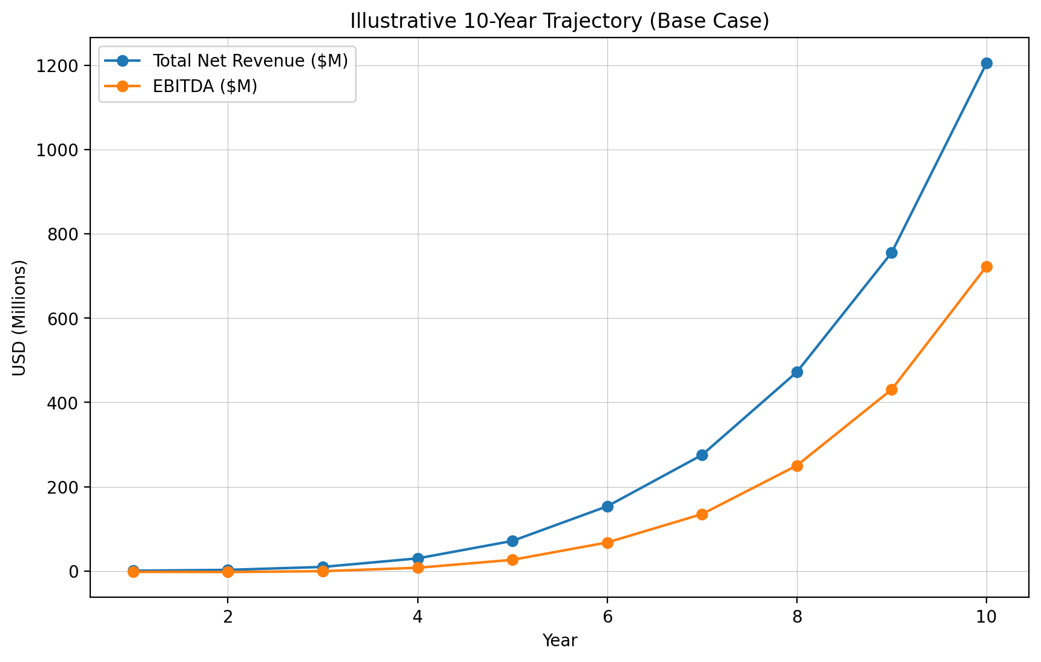
Illustrative net revenue + EBITDA
Year | Avg MAU | Paying Users | Total Net Rev ($M) | EBITDA ($M)
1 | 25000 | 250 | 0.41 | -2.20
2 | 100000 | 1500 | 2.46 | -2.66
3 | 300000 | 6000 | 9.44 | -0.63
4 | 750000 | 18750 | 29.70 | 7.42
5 | 1500000 | 45000 | 71.17 | 26.33
6 | 3000000 | 96000 | 153.40 | 67.50
7 | 5000000 | 170000 | 275.29 | 134.89
8 | 8000000 | 288000 | 472.11 | 250.22
9 | 12000000 | 456000 | 755.63 | 430.71
10 | 18000000 | 720000 | 1,205.17 | 723.10

6) Milestones
- Beta: ship web app shell + 5 feeds + Calendar/Location + wallet connect + twice-daily withdrawal UX + Guardian Hub SOPs.
- Launch gate: 250 paying users or $1M gross receipts + policy versioning + audit logs.
- Scale: deepen Creator Rooms, ticketing, commerce, and safety automation.

