LTMiningNetwork Guild Report — LTMiningNetwork Universe (Beta)
Project: LTMiningNetwork / “LTMiningNetwork Reality / LTMiningNetwork Universe”
Tagline: Mining Miracles Everyday — Connect. Plan. Stream. Earn. Stay Safe.

This document consolidates the latest module map, feed model (5 feeds), pricing ladder, safety + location systems, calendar-first events flow, and creator/mining economics for the LTMiningNetwork Universe beta. Live Hub references have been removed; streaming is housed under LTRStream.

Visual Direction Snapshot
Current design direction (cosmic + rainbow gradient UI across web and mobile):
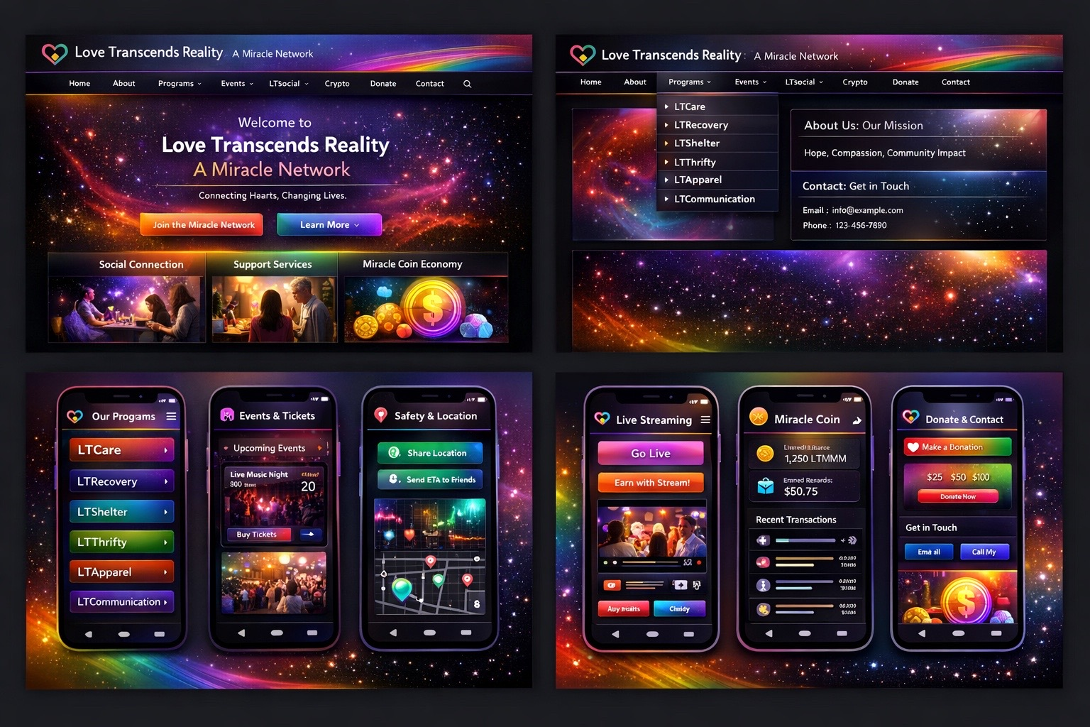

1) Executive Summary
LT Social is a safe social universe that combines five layers into one connected product:
- A social app (posts, messaging, connections, creator tools)
- A streaming hub (native streaming + creator economy)
- A marketplace (digital goods/services + optional token rails)
- An economic layer (mining, rewards, token mechanics)
- A safety layer (IA Rainbow Guardian, family-safe controls, temporary location sharing)
Defining idea: relationships and visibility are tiered, so users can safely share more with trusted circles while still maintaining a public-facing creator presence.

2) Whole-Site Mockup Scope
“Whole site” means two connected experiences:

2.1 Marketing / Investor / Docs Site (Public)
- Landing (value proposition)
- Features (social, safety, streaming, marketplace, mining)
- Products (LTCare, LT Reality & Cafe, Invest Your Data, etc.)
- Technology (IA Rainbow AI, Shift Coin, token mechanics, wallet demo)
- Investors (revenue model, roadmap, investor relations)
- Pricing (subscription plans)
- Legal/Policies (privacy, terms, safety standards)
- Contact / Community

2.2 Web App (Logged-in Universe)
- Home feed (multi-feed tabs)
- Profile
- LTRStream (Go Live + Streams + Replays)
- LTMarket
- LTMessaging
- Connections (relationship tiers)
- LTMiningNetwork (Shift Protocol dashboards)
- IA Rainbow Guardian Hub (safety + moderation + admin tools)
- LTCare
- Settings

3) Navigation (App Drawer + Section Map)
App Drawer (module switcher):
- Home
- Profile
- LTRStream
- LTMarket
- LTMessaging
- Connections
- LTMiningNetwork
- IA Rainbow Guardian Hub
- LTCare
- Settings
- User Card + Logout
Rule of thumb: the drawer switches modules; each module can have its own internal tabs and sub-pages.

4) Feed Model Update — 5 Feeds (Public Included)

4.1 The 5 Feeds (Visibility + Intent)
- Public — default discovery surface (Explore, hashtags, trending, map/event promos). Viewable broadly, subject to safety filters.
- Fanship — creator/follower layer (fans, subscribers, supporters). Free or subscriber-gated depending on plan.
- Friends — mutual connections; social-first real-life layer.
- Inner Circle — high-trust layer (location share, emergency check-ins, private events).
- Creator Rooms — paid/premium channels for exclusive posts, replays, ticket drops, behind-the-scenes.

4.2 Posting Rule (How Content Routes)
Every post selects:
- Feed target: PUBLIC | FANSHIP | FRIENDS | INNER_CIRCLE | CREATOR_ROOM
- Post type: text, photo, short video, long video, event, listing, clip, livestream announcement
- Safety mode: family-safe / mature / restricted tags
- Optional monetization: paywall, tip jar, subscriber-only, ticket link

4.3 Creator Monetization by Feed (Default Model)
- Public: tips, affiliate links, sponsored posts (optional limited paywalls)
- Fanship: subscriptions, gated posts, replay paywalls
- Friends: private commerce, group events, referral bonuses
- Inner Circle: safety-first features, private meetups, trusted sales
- Creator Rooms: highest ARPU (paid membership, premium drops, PPV streams)

5) Subscription Tiers (Current Draft)

5.1 SelfCelebrity — $50/month (Most Popular)
- Unlimited connections
- Enhanced creator features
- Verification badge
- Revenue split label: 30/30 (see Section 6)

5.2 4Family — $100/month (Family Safe)
- Family-focused features
- Parental controls
- Content filtering
- Priority support
- Household account management

5.3 Miner — $250/month
- Enhanced mining capabilities
- Priority chain selection
- Higher mining rewards/better rates
- Priority mining access

5.4 Pearl — $350/month (Pro)
- Pro tier features
- VIP support
- Revenue split label: 25/50 (see Section 6)

5.5 Jasper — $500/month (Elite)
- Enterprise/elite features
- Unlimited connections
- White-label options (branding, custom domain, custom app skin)
- Revenue split label: 20/40 (see Section 6)

5.6 4Family Plus — Price TBA (Coming Soon)
- 1–2x weekly family therapy options (where offered)
- Family wellness tracking
- IA Rainbow Guardian family sessions
- Licensed therapist access placeholders

5.7 Reconciling Older Pricing Cards
If legacy enterprise pricing exists (e.g., $5,000/month), label clearly as “Legacy / Enterprise Pilot Pricing” and keep the $50–$500 ladder as “Public Beta Pricing,” or consolidate the $5,000 plan under Jasper Enterprise.

6) Revenue Split Labels (Define the Math)
UI labels like 30/30, 25/50, 20/40 must be defined consistently so users understand what they mean.
Recommended definition (clean + shippable):
- Creator Share % — what the creator keeps from monetized content
- User Rewards % — what gets redistributed to users (engagement, referrals, community actions)
- Platform % — operations, compliance, infra, safety costs
Example mapping (tunable later; the key is consistent labeling):
Label | Creator Share | User Rewards | Platform
30/30 | 30% | 30% | 40%
25/50 | 25% | 50% | 25%
20/40 | 20% | 40% | 40%

7) Core Modules — Product Requirements (Ship List)

7.1 Home (Multi-feed + Explore)
- Top tab bar: Public / Fanship / Friends / Inner Circle / Creator Rooms
- Composer: media, events, marketplace listing, clip, Go Live
- Safety defaults: filtering, rate limits, report/block, comment throttling

7.2 Profile
- Identity + verification state
- Shelves: Posts, Streams, Store, Events, Playlists
- Monetization panel: subscriptions, paywalls, Creator Rooms, payouts, analytics

7.3 LTRStream (Streaming)
- Go Live (native streaming)
- Connect Twitch (bridge mode via OAuth)
- Chat moderation tools
- Replays saved to Profile or Creator Rooms with optional paywall

7.4 LTMarket (Marketplace)
- Listings: goods/services/digital
- Seller profile + ratings
- Checkout: card/Apple Pay/Google Pay; token optional where compliant
- Creator storefronts (Jasper white-label)

7.5 LTMessaging
- Tiered messaging permissions (Public DMs limited; Fanship DMs allowed; Inner Circle always allowed)
- Optional paid DMs
- Media messages + safety scans

7.6 Connections
- Upgrade/downgrade tiers (Fanship ↔ Friends ↔ Inner Circle)
- Tier-based visibility rules + invite restrictions
- Inner Circle unlocks safety tools

7.7 LTMiningNetwork (Shift Protocol)
- Earnings dashboards
- Device status + boost status
- Chain selection + optimization
- Rewards history export

7.8 IA Rainbow Guardian Hub (AI Guardian)
- User safety status + risk signals
- Creator moderation settings (filters, keyword rules, ban lists)
- Admin tools: anomaly flags, blocklists, suspicious activity review

7.9 LTCare
- Wellness content
- Family-safe tools integration
- 4Family Plus therapy scheduling placeholders

7.10 Settings
- Privacy defaults per feed
- Safety presets (location sharing + emergency contacts)
- Subscription + billing
- Connected accounts (Twitch, calendars)

8) Safety + Temporary Location Sharing (Inner Circle Power Feature)
Temporary sharing:
- 15 min / 1 hr / until ended / custom duration
- Inner Circle only by default
- Stop sharing always visible
- Audit log: who could view, when, and why
Check-ins:
- Arrived / Leaving / Home Safe
- Route deviation prompts (optional)
- Escalation ladder: ping Inner Circle → emergency contact → optional emergency call

9) Events + Tickets (Calendar-First)

9.1 Event Object Model
- Title, host, location, time
- Ticket tiers, capacity, refund rules
- Safety rating + restrictions (family-safe, 18+, etc.)
- Category filters + accessibility flags

9.2 Core Flow
Discover → Details → Buy Ticket → RSVP → Invite → Add to Calendar → Reminders → Post-event recap

10) Location & Calendar Layers (Network Effects + Mining Multipliers)

10.1 Calendar Sharing on the Network
- Events can be shared as posts to any feed (Public/Fanship/Friends/Inner Circle/Creator Rooms).
- Invites create a lightweight RSVP object that can spawn a group chat thread (Friends/Inner Circle).
- Calendar sync writes to Google/Apple calendars with smart reminders (travel time, conflicts, start time nudges).
- After the event: attendees can post recaps, clips, and reviews that link back to the event object.

10.2 Location Signals for Safety and Future Mining (Proposed)
Location data should be opt-in, minimal, and privacy-preserving. The goal is twofold: (1) keep people safer when they go out, and (2) later power mining/network multipliers without exposing precise personal movement.
- Safety mode (Inner Circle): real-time location sharing with expiry timers and visible stop controls.
- Event mode: optional check-in at venues (geofenced) to confirm attendance without continuous tracking.
- Aggregation: use coarse location buckets + time windows for analytics; store precise coordinates only when strictly required for active safety sharing.

10.3 Mining Multipliers Using Location + Event Participation (Proposed)
Once LTMiningNetwork is active, location-informed multipliers can reward real-world participation and verified community actions while keeping consent and transparency front-and-center.
- Verified attendance multiplier: bonus mining rate when a user checks in to a ticketed/verified event (opt-in).
- Network density multiplier: small boosts when friends/inner-circle attend together (proof-of-presence without public disclosure).
- Safety compliance multiplier: optional reward for using check-ins (Arrived/Home Safe) and completing safety prompts.
- Venue/partner beacon multiplier: higher boosts for partner venues that can cryptographically attest check-ins (future feature).
- Anti-fraud: combine device integrity + rate limits + anomaly detection in IA Rainbow Guardian.
Important: multipliers must be explained clearly in UI (what data is used, for how long, and how to disable). Default should be OFF until user opts in.

11) Figma Build Spec (Pages + Frames)

11.1 Figma Pages
- 00 — Cover & Links (overview + clickable sitemap)
- 01 — Design System (colors, type, icons, spacing)
- 02 — Components (nav drawer, top tabs, plan cards, modals, forms)
- 03 — Marketing Site (Desktop) (landing + features + pricing + investors)
- 04 — Marketing Site (Mobile) (same pages, mobile layout)
- 05 — Web App Shell (drawer + top bar + floating actions)
- 06 — Home & Feeds (5-feed tabs + composer + post cards)
- 07 — Pricing & Paywalls (plan grid + checkout + manage subscription)
- 08 — Creator Tools (analytics + paywalls + Creator Rooms)
- 09 — Streaming (Go Live, live room, replay page)
- 10 — Marketplace (browse, listing detail, cart/checkout)
- 11 — Messaging (inbox, chat, safety tools)
- 12 — Safety & Location (share flow, check-ins, emergency)
- 13 — Admin / AI Guardian (dashboards + moderation)
- 14 — LTCare (family-safe hub + 4Family Plus placeholders)

11.2 Core Frame Sizes
- Mobile: 390×844
- Desktop: 1440×900
- Tablet (optional): 834×1194

11.3 Key Frames to Draw First (MVP Set)
Marketing (Desktop + Mobile):
- Landing
- Features
- Pricing
- Investors/Roadmap
- Technology/Wallet Demo
Web App (logged-in):
- App Shell (drawer open/closed)
- Home feed with 5 tabs
- Plan selection + checkout
- Streaming page + live room
- Marketplace browse + listing detail
- Connections tier manager
- Location share panel
- Calendar sync modal (Add to Calendar + reminders)

12) UI Copy / Labels Checklist
- Home feed tabs: Public / Fanship / Friends / Inner Circle / Creator Rooms
- Replace “paywalls for 3 feeds” with “monetize across all 5 feeds” (or limit Public paywalls, but state it clearly)
- Pricing cards: SelfCelebrity $50, 4Family $100, Miner $250, Pearl $350, Jasper $500, 4Family Plus TBA
- Plan badges: Most Popular (SelfCelebrity), Family Safe (4Family), Pro (Pearl), Elite (Jasper)
- Remove all mentions of “Live Hub”; use LTRStream as the streaming entry point

13) Next Implementation Notes (Engineering-Ready)
- Persist feed selection on every post: visibility_channel = PUBLIC|FANSHIP|FRIENDS|INNER_CIRCLE|CREATOR_ROOM
- Enforce access at API layer and UI layer (deny-by-default for Inner Circle and Creator Rooms)
- Centralize revenue split definitions and display labels everywhere
- Create plan entitlements matrix (plan → features → limits) and enforce via feature flags
- Safety-first defaults: posting, messaging, live chat moderation, anti-harassment protections
- Location data: opt-in, minimal retention, clear UI controls, audit logs; separate “Safety sharing” from “Mining signals”

Appendix A — Plan Entitlements Matrix (Starter)
Feature | SelfCelebrity | 4Family | Miner | Pearl | Jasper
Unlimited connections | ✅ | ✅ | ✅ | ✅ | ✅
Verification badge | ✅ | — | — | ✅ | ✅
Family controls | — | ✅ | — | — | ✅ (white-label add-on)
Mining boosts | — | — | ✅ | ✅ | ✅
VIP support | — | ✅ (priority) | — | ✅ | ✅
White-label | — | — | — | — | ✅
Creator Rooms | ✅ | — | — | ✅ | ✅

13) LTMiningNetwork DNS/VPN Mining Service (Sustainable “Bandwidth Mining” Layer)
This section defines how LTMiningNetwork can offer a “mining” experience on mobile and web without doing energy‑intensive proof‑of‑work hashing. Instead, the protocol rewards users for providing useful network resources (secure bandwidth relay + encrypted DNS), with optional on‑chain settlement.

13.1 What it is (and what it is not)
- What it IS: a privacy‑preserving VPN/proxy relay that can route approved traffic through user devices (opt‑in), turning unused bandwidth into a metered resource that can be rewarded.
- What it IS NOT: Bitcoin-style proof‑of‑work mining. PoW requires continuous computation to solve puzzles; routing traffic through a VPN does not validate blocks or perform PoW hashing.

13.2 Reference models (real-world analogs)
LTMiningNetwork can be positioned alongside existing bandwidth marketplaces where node runners earn based on traffic volume and demand.
- PacketStream explicitly pays users for bandwidth shared and publishes a per‑GB payout rate ($0.10/GB).
- Honeygain describes earning by securely sharing unused internet bandwidth (credits per MB) through an encrypted network.
- Mysterium describes running nodes that sell bandwidth for VPN access and earning crypto based on traffic volume, with earnings impacted by IP location and connection stability.

13.3 How it works (mobile + browser)
- Mobile app: an in-app VPN profile (Android VPNService / iOS NetworkExtension where allowed) establishes an encrypted tunnel to LTMiningNetwork edge, then relays whitelisted requests. User controls include daily caps, quiet hours, kill switch, and audit log.
- Web app: a browser extension connects to the same relay network (no device-wide VPN), enabling “session relay” for approved tasks and supporting account-level rewards.
- DNS layer: DNS-over-HTTPS (DoH) encrypts DNS lookups between the client and resolver, preventing passive observers from reading or tampering with DNS queries. This improves privacy and reduces manipulation risk for high-value actions like checkout and wallet operations.

13.4 Compliance + safety constraints (must-have)
- Traffic policy: default to whitelisted categories (e.g., ad verification, performance testing, public-web crawling) and disallow high-risk categories by policy.
- User controls: one-tap pause, bandwidth caps, device-only mode, and clear disclosures (what is routed, when, and how rewards are computed).
- Abuse prevention: reputation scoring, anomaly detection, and rate limits in the IA Rainbow Guardian Hub.

14) Location + Calendar Data for Network Multipliers (Opt-in)
To align safety + events + mining, LTMiningNetwork uses opt‑in signals from Location Sharing and Calendar RSVPs to award multipliers that encourage healthy network behavior.

14.1 Location multipliers (opt‑in only)
- Concept: similar to how bandwidth marketplaces value certain regions more due to demand, LTMiningNetwork can apply regional multipliers when opt‑in location is enabled (e.g., high-demand metro areas).
- Safety-first: location is only collected when a user explicitly enables it (Inner Circle defaults), with timers (15 min / 1 hr / until ended) and an always-visible stop button.
- Privacy model: store coarse location (geohash bucket) for multiplier computation; never store exact trails unless the user is actively using a safety session.

14.2 Calendar-based multipliers (event sharing)
- Event RSVP → Calendar Sync: When users add an event to calendar and check in, they generate “proof of presence” signals that can boost mining multipliers.
- Network benefit: predictable event waves help allocate relay capacity (more users online → more capacity).
- Anti-fraud: check-in requires cryptographic nonce + device attestation (where available) + anomaly checks in the Guardian Hub.

15) Updated Earning Projection (Illustrative)
These projections are illustrative product-model estimates (not financial advice). They use publicly stated bandwidth payout rates from existing services as reference points and should be tuned with LTMiningNetwork’s own unit economics.
Scenario | Shared Bandwidth | Reference Payout | Gross / Month | Notes
Conservative | 2 GB/day | $0.10/GB | $6 | Comparable to low-demand bandwidth share usage.
Expected | 10 GB/day | $0.10/GB | $30 | Requires stable connection + demand in region.
High Demand | 25 GB/day | $0.10/GB | $75 | Higher utilization; apply caps to protect users.
Premium Mobile | 10 GB/day | $0.20/GB | $60 | Some platforms pay higher on certain devices/IPs.
Multiplier layer: LTMiningNetwork can apply multipliers (e.g., 1.1× to 2.0×) for verified accounts, stable uptime, event check-ins, and opt-in location buckets—while enforcing strict privacy controls and daily caps.

16) New Mockups (Website + App + Mining Dashboards)
The following mockups represent the updated LTMiningNetwork branding and modules. (Concept UI for planning.)
382FE695-95C6-4A7B-88A9-E5BFEFA06885.jpeg
LTMiningNetwork_landing_mock.png
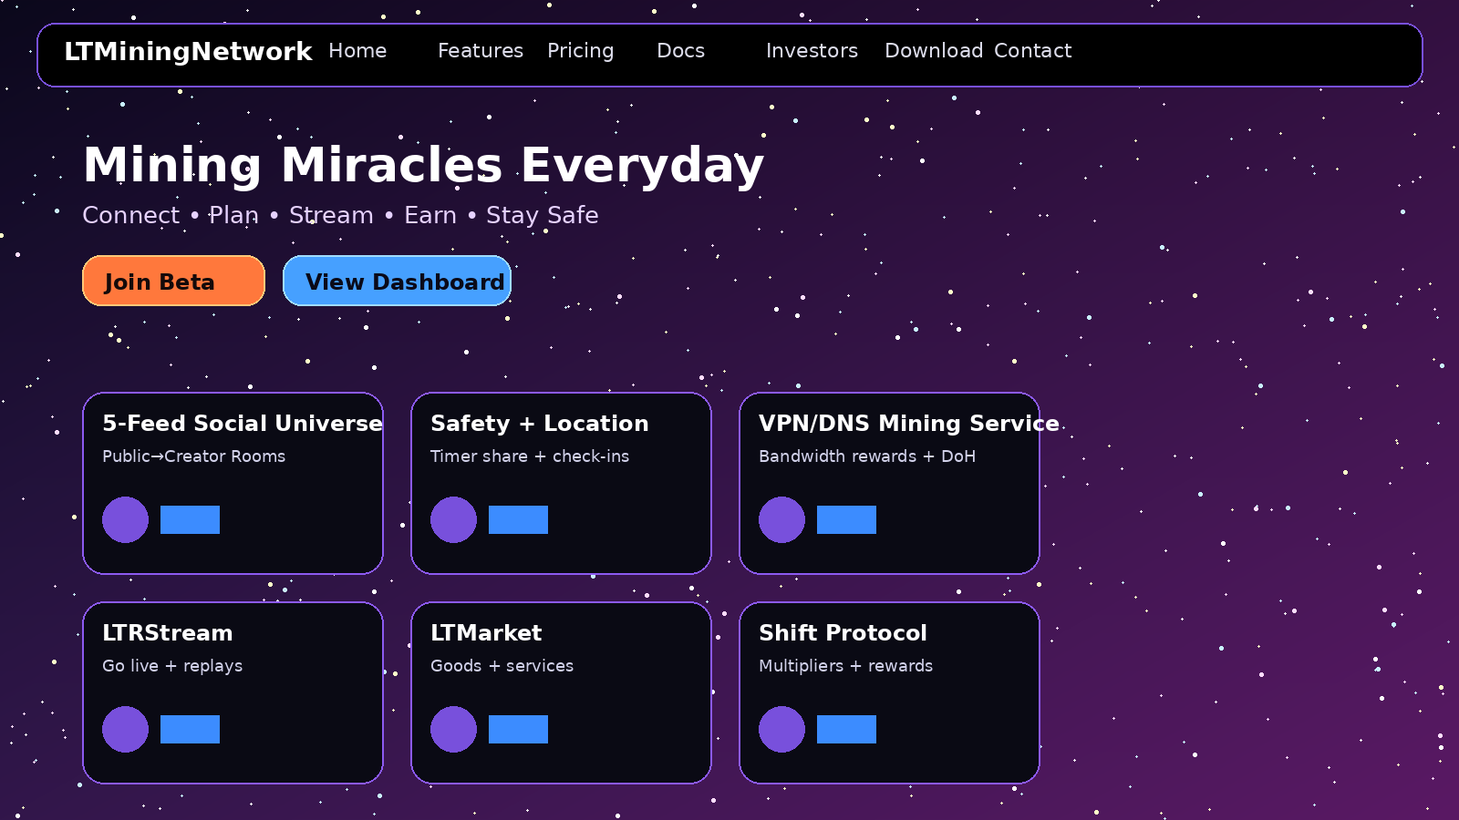
LTMiningNetwork_dashboard_mock.png
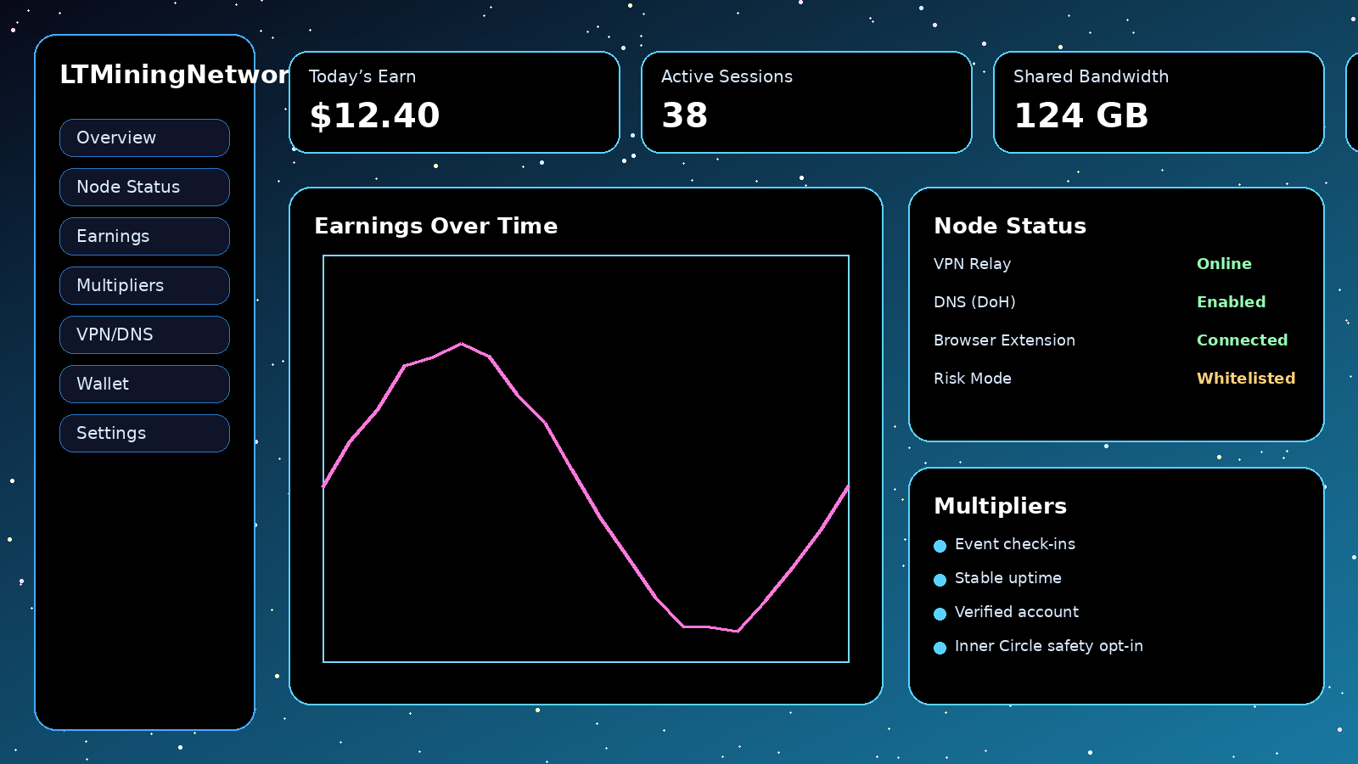
LTMiningNetwork_vpn_dns_mock.png
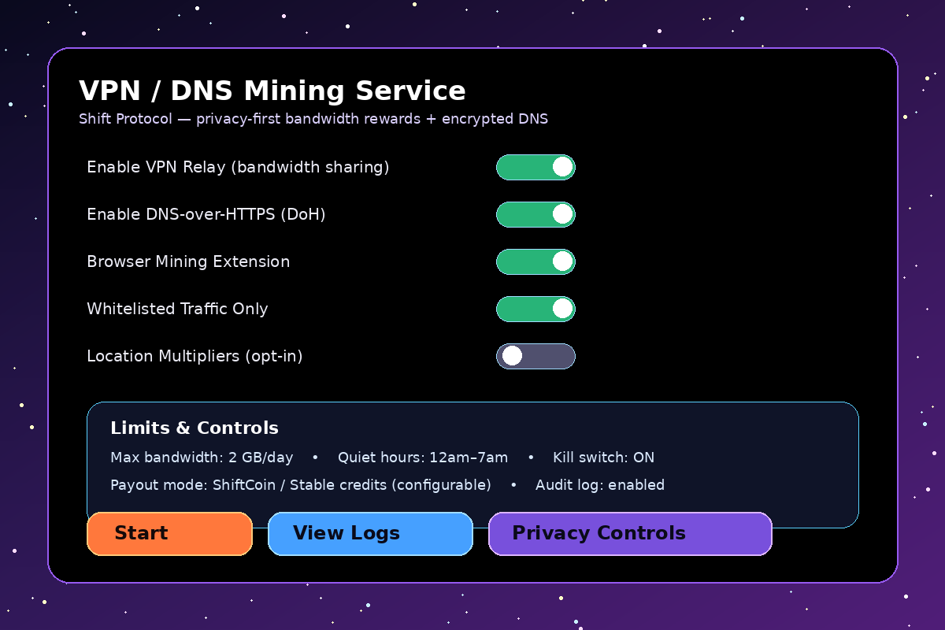

17) Network Unit Economics (Illustrative) — Buyer $/GB vs Node Payout $/GB
A sustainable business model typically separates (a) what customers pay for proxy/VPN egress bandwidth and (b) what node operators earn per GB. For example, some proxy networks advertise buyer pricing around $1.00/GB while paying node runners around $0.10/GB; the difference funds operations, fraud control, and support.
Example Metric | Illustrative Value | Comment
Buyer price (proxy/VPN egress) | $1.00/GB | Reference example from a proxy network’s public pricing.
Node payout (bandwidth share) | $0.10/GB | Reference example from the same network’s public payout rate.
Gross margin (before overhead) | ~$0.90/GB | Used for ops + compliance + safety + growth.
Scale examples (monthly): 1,000 nodes × 10 GB/day ≈ 300,000 GB/month. At $1/GB buyer pricing, gross revenue ≈ $300k/month; at $0.10/GB payout, node earnings ≈ $30k/month (before multipliers, demand variance, and caps).

18) Technical Clarification: VPN/DNS Privacy vs Blockchain Consensus
LTMiningNetwork’s VPN + encrypted DNS layer improves privacy and integrity of network requests (e.g., login, content fetches, and wallet UIs). However, blockchain consensus security (e.g., proof-of-work or proof-of-stake) is separate. Bitcoin-style hashing is computation-heavy proof-of-work; it is not performed by routing traffic through a VPN. If LTMiningNetwork settles rewards on-chain, it should prefer energy-efficient chains/consensus (e.g., proof-of-stake) and keep relay accounting off-chain with auditable logs.

19) Sources (for pricing, bandwidth mining, DNS encryption, and sustainability)
- PacketStream pricing and bandwidth-sharing payout examples: packetstream.io (pricing + share bandwidth pages).
- Honeygain bandwidth-sharing overview and earning model: honeygain.com (features/support pages).
- Mysterium node earning model (traffic volume, IP location, stable connection): mystnodes.com / mysterium.network blog/docs.
- DNS-over-HTTPS definition and purpose (encrypt DNS lookups): Webopedia (DNS over HTTPS).
- Proof-of-work vs proof-of-stake energy and mechanism overview: Britannica Money; Ethereum PoS energy reduction: Investopedia.

