V3 LTReality Mining Report
LTReality Mining Report (Full Web3, VPNMine, DNS, Multi-network proofs)
Mining Miracles Everyday - Connect. Plan. Stream. Earn. Stay Safe.

V3 | Generated: 2026-01-31 | Domains: lovetranscendsreality.org and LTSocial.net

1. Executive Summary
This report defines a cohesive product, business model, technical scope, and 10-year financial baseline for the Love Transcends ecosystem (LTSocial.net and lovetranscendsreality.org). Each version is designed to be independently shippable, with clear guardrails around app-store compliance and realistic operating costs.

2. Version Definition
V3 is the full long-range Web3 build: V2 plus VPNMine (privacy-preserving network contribution), multi-network proofs, decentralized naming/DNS features, and enterprise/node licensing. This version is the most technically ambitious and has the highest compliance and operational complexity.

3. Scope Matrix (What Ships in This Version)
Feature | V3
Marketplace (digital goods: photos, videos, AI music, NFTs/collectibles) | ✅
Live streaming (native) + Twitch connect | ✅
Tips + one-time pay-per-view posts | ✅
Weekly subscription to creators (Fanship) | ✅
Friendship feed (invite-only via Friendship Code) | ✅
Hidden view counter for creator only | ✅
Messaging (friendship-only, optionally paid fan inbox in later versions) | ✅
Sponsor Boost (paid amplification for posts/events) | ✅
Calendar + Events + Tickets (Apple/Google calendar integration) | ✅
Location safety (temporary share, check-ins, event map) | ✅
AI Guardian safety + moderation | ✅
Therapist layer / 4Family Plus (regulated) | ✅
Reality Coin (RC) wallet + top-ups + spending | ✅
VPN-based mining network (verified mining) | ✅
Cash-out (2x/month, max $1,000; crypto wallet transfer) | ✅
Post minting (on-chain proofs; NFT-style ownership) | ✅
Multi-network proofs (fast chain + second chain proofs) | ✅
Decentralized DNS / naming (human-readable IDs, wallet handles) | ✅
Node licensing / enterprise services | ✅
Legend: ✅ included in this version; — not included or deferred.

4. Positioning: Tech-First, Safety-First Social Commerce
The mainstream differentiator is not 'another social feed'. It is a tech-first social commerce system with three pillars: (1) creator monetization that is easy to understand, (2) safety controls that are visible and default-on, and (3) modular permissions so users can share differently across audiences.
Key promises (user-facing):
- Earn through your content: tips, one-time paid unlocks, and weekly subscriptions.
- Sell digital goods instantly: AI-created music, photos, videos, and collectible-style items.
- Friendship Code makes the private 'friendship layer' opt-in and spam-resistant.
- Creators see metrics; viewers do not get pressured by public counters.
- Safety guardrails: report/block, comment limits, and optional AI Guardian filters.

5. Product Experience Model

5.1 Feeds and Visibility
LT Social uses a simple two-layer feed model in the mainstream build (plus optional public discovery where allowed):
- Fanship Feed: paid content surface for streamers and creators (PPV posts, weekly subs, subscriber-only drops).
- Friendship Feed: invite-only via Friendship Code; designed for real-life circles; posting is non-paywalled by default.
- Optional Public/Explore: discovery surface with strict safety filters and no private messaging access by default.

5.2 Hidden Creator View Counter
Each post tracks a view counter visible only to the original poster (creator) and platform admins. Viewers do not see view counts, to reduce social pressure and manipulation. The creator dashboard includes: unique viewers, repeat viewers, unlock conversions, refunds/chargebacks, and retention.

5.3 Messaging Rules
Messaging is friendship-gated: users can only DM if they have exchanged Friendship Codes (or are in the same approved inner circle/group). This reduces spam and makes the platform safer by default.
V2+ optional: creators can enable a 'Paid Fan Inbox' where fans can send a paid message request that either gets accepted, refunded, or converted into a tip. This feature is web-first due to store policy complexity.

6. Marketplace and Creator Profiles

6.1 Digital Marketplace (Core)
The Marketplace sells digital goods only in early stages to keep operational risk low (no shipping, no chargeback disputes about physical delivery).
- Digital listings: AI music tracks, AI photos, AI videos, templates, presets, short clips, and collectible-style items.
- Optional 'collectible' mode: a limited quantity listing with a certificate of authenticity (V1) or on-chain minting (V2/V3).
- Royalty-friendly design: creators can set a resale royalty for collectible-style items in V2/V3.
- Refund policy: digital purchases are final by default; limited refunds only for platform errors (policy must be explicit).

6.2 Payout Split
Marketplace split: creator receives 80% of each sale; platform retains 20% for operations, moderation, storage/bandwidth, and payment processing buffers.

6.3 Creator Profiles
Creator profiles unify streaming + store + paid posts. The profile includes: storefront, subscription options, PPV catalog, stream schedule, and verified badges.
- Upload tools: bulk upload, pricing, metadata, content rating (family-safe / mature), and license terms.
- Live streaming: go live, schedule streams, replays, clips, and tip goals.
- Analytics: revenue, conversion funnels, buyer cohorts, and audience retention.
- Privacy: viewer identity can be anonymous to creators for purchases (buyers appear as 'Anonymous Buyer' unless they opt in).

7. Monetization and Transaction Rules

7.1 Paid Content Options
- One-time unlock (PPV): viewer pays once to unlock a post or replay.
- Weekly subscription: viewer pays a recurring weekly fee set by the creator.
- Tips: one-time support payments during streams or on posts.
- Friendship repost license: reposting content into Friendship Feed can require a $5 license paid directly to the original creator wallet (anti-spam + creator support).

7.2 Platform Fees (Baseline)
Standard platform fee on paid content (tips/PPV/subscriptions): 17% of the creator-set price. Marketplace takes 20%.
Beta incentive (optional): for early traction you can run a limited promo where platform fee drops to 5% until either 250 paying users or $1,000,000 of processed volume (whichever comes first).

7.3 Store Policy Reality Check
On iOS and Android, digital goods sold in-app may require Apple/Google in-app purchase systems, which impose platform commissions. To remain compliant, V1 assumes in-app purchases for mobile and a parallel web checkout for desktop where permitted.
Reference fee frameworks: Apple App Store commissions and subscription rules, and Google Play service fees. See References section for official sources.

7.4 Reality Coin (RC) Economics
Reality Coin (RC) is denominated as whole $1 coins in the ecosystem. There are no fractional coins. All calculations round up to the next whole RC. Supply cap target: 777 trillion RC.

7.4.1 Top-Up Rate Schedule
- Phase A (Boost): $1 deposit -> 4 RC for the first 20 deposits.
- Phase B (Reduced Boost): after 20 deposits and before 6 months -> $1 deposit -> 2 RC.
- Phase C (Standard): after 6 months from first top-up -> $1 deposit -> 1 RC permanently.
- Priority rule: once Phase C begins, it overrides A/B forever.
- Rounding rule: USD amounts are rounded up to whole dollars before applying the multiplier.

7.4.2 Cash-Out and Conversion Controls (Web-First)
To reduce regulatory and fraud exposure, conversion and cash-out are web-first and gated by verification. Mobile apps can show balances and allow in-app spending, while off-platform conversion remains outside the app store purchase flow.
- Withdrawal frequency: maximum 2 withdrawals per month.
- Withdrawal cap: maximum $1,000 per withdrawal.
- Default off-ramp: user transfers to a supported crypto wallet, then converts to USD bank (third-party rails).
- Cash-out spread (post-launch target): user receives up to 75% of withdrawable value; platform retains up to 25% to fund reserves, compliance, and fraud loss buffers.
- Beta safeguard option: temporarily stricter cash-out (for example user 25% / platform 75%) until official launch and liquidity targets are reached.

7.4.3 Avoiding Arbitrage
If deposits grant bonus RC (e.g., 4 RC for $1), the safest model is to treat bonus RC as spend-only credits that are not withdrawable for cash. Withdrawals return the user's deposited principal (minus fees) while bonus is redeemed only through in-app goods/services.

8. Safety, Moderation, and Compliance
Safety is a first-class product system, not a policy page. The platform must ship with clear user controls, creator tools, and enforcement workflows.
- Age gating and content ratings: family-safe defaults plus mature content tags.
- Report/block/mute with rapid enforcement queues.
- Comment and messaging guardrails (limits, cooldowns, and friendship gating).
- Automated detection for harassment, scams, and child safety risks (with human review escalation).
- Transparent enforcement: warnings, strikes, and appeal flow.
V2/V3 also require compliance posture for wallet, conversion, and potential money-transmitter rules. This includes KYC/AML where required, sanctions screening, audit logs, and a formal incident response plan.

8.1 AI Guardian and Location/Calendar Safety
- AI Guardian Hub: creator moderation presets, keyword filters, and anomaly detection.
- Temporary location sharing: 15m / 1h / 4h / until off; opt-in, off by default.
- Safety check-ins: 'Arrived', 'Leaving', 'Home Safe' with trusted contacts.
- Calendar + Events: create events, share to feeds, sell tickets (phase 2), and integrate with device calendars.

9. Technical Architecture (Buildable)
High-level architecture is designed for modular expansion. Start with a single API and modular services, then split into dedicated services as load grows.

9.1 Core Services
- Web app: Next.js/React (marketing + web app shell).
- Mobile app: React Native or Flutter (thin native shell + modules).
- Backend API: FastAPI (or Node) with modular routers for Feed, Market, Payments, Identity, Safety, and Streaming.
- Data: Postgres for relational data; Redis for caching/rate limiting; object storage (S3-like) for media.
- Search: OpenSearch/Meilisearch for discovery.
- Realtime: WebSockets for chat and live interactions.

9.2 Media and Streaming
- Live streaming: start with a managed service (AWS IVS or similar) to reduce operational complexity.
- Replays and VOD: store in object storage; generate adaptive bitrate ladders.
- Content scanning: virus scan, malware detection, and basic moderation checks on upload.
- Bandwidth controls: per-plan caps and encoding presets.

9.3 Wallet and Ledger (RC)
- Separate USD ledger vs RC ledger; every transaction is immutable and auditable.
- Feature flags: transfers/conversion disabled by default; enable per region and compliance readiness.
- Deterministic top-up multiplier logic (Phase A/B/C) enforced server-side.
- Withdrawal engine: two-per-month limit + $1,000 cap + risk scoring + manual review queue.

9.4 VPNMine and DNS (Long-Range)
V3 adds a network layer that looks like a privacy VPN plus a decentralized naming system. This must be built with strong anti-abuse controls and a clear compliance posture.
- VPNMine client: encrypts traffic; can optionally contribute bandwidth to approved nodes (opt-in).
- Proof-of-contribution: measure bandwidth or uptime without exposing user identity (privacy-preserving proofs).
- Multi-network proofs: anchor important events (minting, payouts) to two networks for redundancy.
- Decentralized DNS/naming: human-readable handles (e.g., @name) that resolve to wallet address, profile, and public keys.
- Enterprise DNS: paid resolvers, custom domains, and security services for brands/communities.

10. Delivery Roadmap
- 0-60 days: Stabilize V2 feature set; define on-chain boundaries (what is real vs simulation).
- 3-6 months: Pilot VPNMine with a small, consented node network; build proof-of-contribution measurement.
- 6-12 months: Naming/DNS prototype, multi-network proof anchoring, and enterprise resolver pilot.
- Year 2-3: Community-run nodes, governance model, audited contracts, and regional compliance expansion.
- Year 4-10: Full ecosystem expansion: marketplace scale, enterprise offerings, and multi-chain integrations.

11. 10-Year Financial Baseline (Planning Model)
The financial model below is a baseline planning scenario, not a guarantee. It assumes strong execution, increasing product-market fit, and disciplined cost control. Numbers are in USD and shown as annual totals.

11.1 Key Model Assumptions
- Users grow from 600,000 to 60,000,000 over 10 years (modeled as CAGR).
- Monthly active rate increases from 40% to 55% as retention improves.
- Paying plan adoption increases from 3.0% to 6.0% of users.
- Marketplace take rate: 20% (creator keeps 80%).
- Paid content take rate: 17% (platform fee on PPV/tips/subs).
- Payment processing reserve: ~3.0% blended (processing + disputes buffer).
- Cloud/infra modeled as % of revenue, declining with scale (from 24% to 12%).
- Headcount grows from 24 to 160 over 10 years; loaded cost per FTE: $205,000/year.
- VPN/Mining premium adoption grows from 1.0% to 3.0% of users.
- Enterprise DNS and node licensing revenues ramp in years 2-10 as B2B offerings mature.

11.2 Baseline 10-Year P&L Snapshot
Year | Users | Total_gross_rev | Total_cost | EBITDA | EBITDA_margin
2026 | 600000 | $26.3M | $24.9M | $1.4M | 5.4%
2027 | 1000860 | $49.7M | $43.0M | $6.7M | 13.4%
2028 | 1669536 | $93.7M | $75.5M | $18.2M | 19.4%
2029 | 2784953 | $176.9M | $134.7M | $42.1M | 23.8%
2030 | 4645582 | $334.1M | $243.8M | $90.4M | 27.0%
2031 | 7749298 | $631.6M | $444.8M | $186.8M | 29.6%
2032 | 12926608 | $1,194.6M | $817.3M | $377.3M | 31.6%
2033 | 21562882 | $2,261.0M | $1,509.5M | $751.6M | 33.2%
2034 | 35969055 | $4,282.2M | $2,799.1M | $1,483.1M | 34.6%
2035 | 60000000 | $8,115.7M | $5,207.1M | $2,908.6M | 35.8%

11.3 Charts
Financial trajectory (revenue, cost, EBITDA):
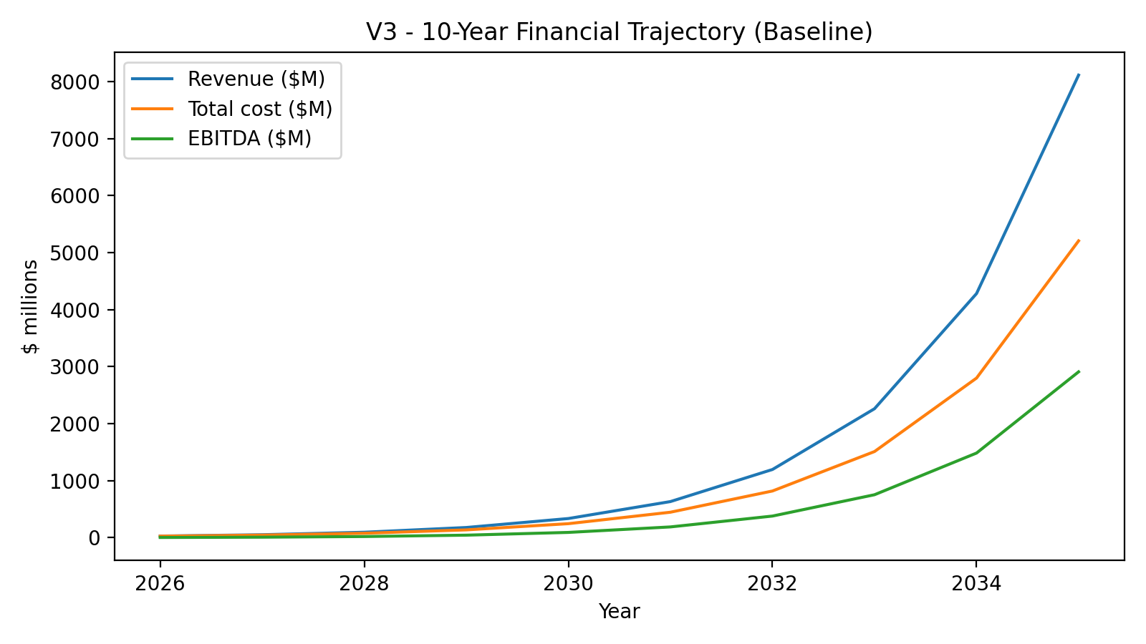
User growth (total users and MAU):
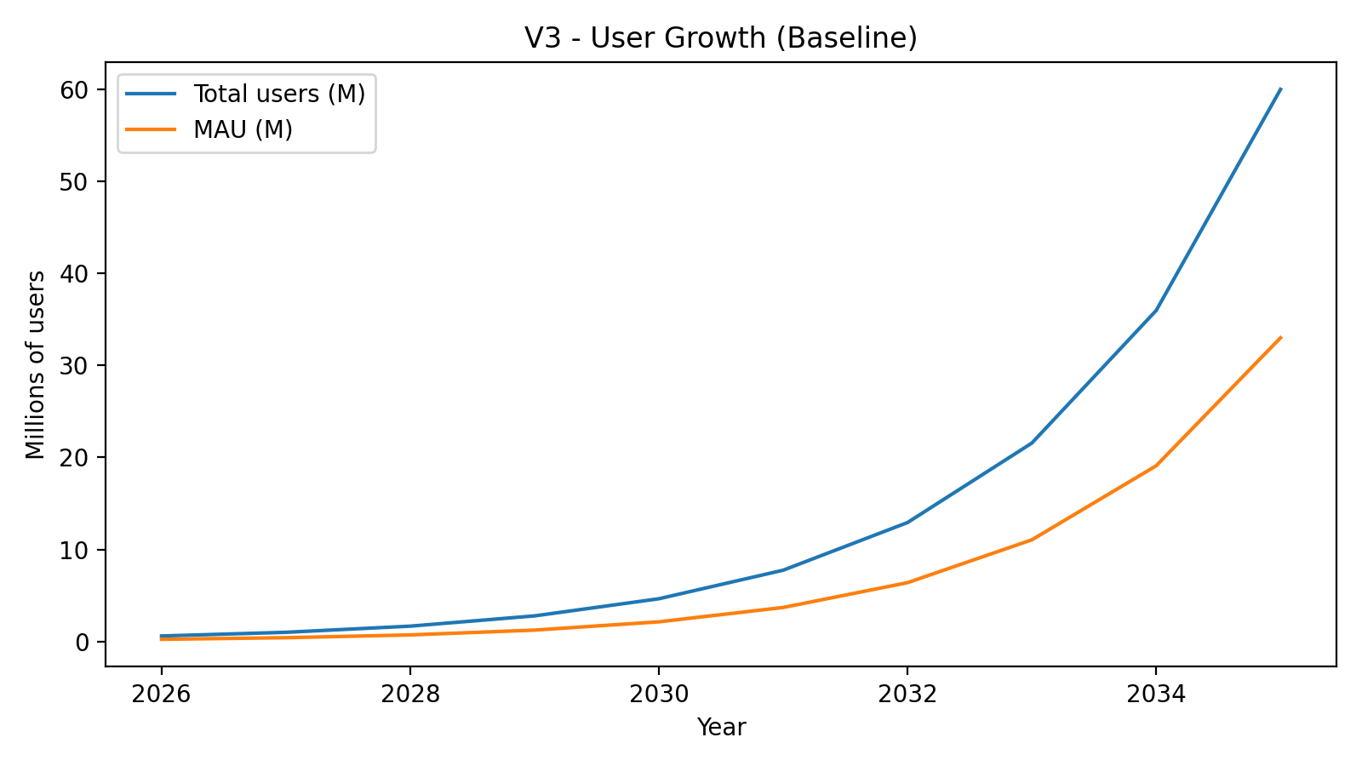

12. Cost Model (What It Takes to Run This)
Costs are modeled as a blend of headcount, infrastructure, and operating overhead. The biggest drivers are moderation/safety (human + tooling) and streaming bandwidth.

12.1 Headcount Plan
Year 1 staffing begins around 24 FTE and scales to ~160 FTE by Year 10 in the baseline. Teams include: Product, Design, Web, Mobile, Backend, DevOps/SRE, Security, Trust & Safety, Data/Analytics, Customer Support, and Partnerships.

12.2 Infrastructure Drivers
- Streaming costs scale with viewer-hours (encoding + delivery).
- Media storage grows with replays, VOD libraries, and marketplace inventory.
- Safety tooling: automated scanning, rate limiting, and logging.
- Search and recommendation systems scale with content volume.

12.3 Compliance and Risk Buffers
- KYC/AML vendor costs (where required) and manual review operations.
- Fraud and chargeback loss reserves.
- Security audits and penetration testing.
- Incident response and monitoring.

13. Risks and Mitigations
- App store policy risk: design payments and digital goods flows to remain compliant; keep conversion web-first.
- Trust & Safety scale: budget for moderation early; use strict defaults (friendship gating, rate limits).
- Fraud/chargebacks: implement risk scoring, velocity limits, and manual review for payouts.
- Creator quality: build onboarding, verification, and anti-copyright infringement controls.
- Regulatory risk (V2/V3): obtain qualified legal counsel for money services, stable-value claims, and therapy features.

14. References (Official Sources)
- Apple - App Store Small Business Program and commission framework: https://developer.apple.com/app-store/small-business-program/
- Apple - subscriptions and commission after one year (overview): https://developer.apple.com/app-store/subscriptions/
- Google Play - Service fee information: https://support.google.com/googleplay/android-developer/answer/112622?hl=en
- Stripe - pricing: https://stripe.com/pricing
- AWS IVS - pricing (managed live streaming): https://aws.amazon.com/ivs/pricing/

