Build Guild File — Love Transcends Reality / LT Social Universe
lovetranscendsreality.org • LTsocial.net • Wix build spec + content copy
Version v1.2 (Tabs + Wix Functions + Reports Merge) • Prepared 2026-01-31

Quick Reference
This is the build guide for updating lovetranscendsreality.org to match the LT Social Universe navigation and to absorb the latest LTsocial + LTReality + mining network reports into a Wix-ready structure. Copy is written in paste-ready blocks (Hero → sections → CTAs).
Compliance note: This document is informational and describes product concepts. Any crypto, therapy, or financial features must be jurisdiction-checked and launched behind feature flags with legal review.

Navigation Summary
Top Tab (Menu) | Sub Tabs (Dropdown) | Wix Page Type | Primary Goal
Features | — | Page (sections + anchors) | Explain the 'safe social universe' and core modules
About | Mission & Vision; Justice & Movement | Folder + subpages | Explain purpose, movement, and governance tone
Products | LTCareAndRecovery; LTCareers & Nonprofits; LTFosterAdoptions; Love Transcends: A Social Miracle Network; LTSoulReality; LTSANP; LTForgivenReserve; Invest Your Data | Folder + subpages | Program pages + signups
LTTechnology | IaRainbow AI; Shift Coin; Token Mechanics; Wallet Demo | Folder + subpages | Explain Operation OneCode, safety, mining, wallet/settlement
Investors | Revenue Model; Strategic Research; Roadmap; Investor Relations | Folder + subpages (gated optional) | Investor narrative, projections, milestones

Current Subscription Tiers Snapshot
Tier | Price (UI Draft) | Highlights
Fanship | $30 / month | Up to 3 connections • Set paywalls for 3 feeds
4Family | $40–$100 / month (pricing draft) | Family features • parental controls • multi-user management
4Family Plus | Price TBA | All 4Family + therapy scheduling (where offered) + family wellness tracking
SelfCelebrity (Most Popular) | $50 / month | Unlimited connections • split shown as 30/30 (define labels)
Miner | $250 / month | Enhanced mining capabilities • priority chain selection
Pearl | $350 / month | Pro tier • split shown as 25/50 • VIP support
Jasper (Elite) | $500 / month | All features • split shown as 20/40 • white-glove service
Define split labels consistently across the UI: Creator Share % / User Rewards % / Platform %. Example: “30/30” = 30% creator, 30% user rewards, 40% platform.

1. Purpose and Audience
- Primary use: a Wix build specification for lovetranscendsreality.org that mirrors the LT Social Universe site structure and contains the latest feature copy.
- Secondary use: an internal alignment doc (product + safety + token mechanics + nonprofit program design).
- Audience: founders, builders, designers, Wix implementers, and investor-facing reviewers.

2. Ecosystem Overview
Love Transcends is positioned as a connected ecosystem of community, commerce, safety, and recovery services — delivered through the LT Social Universe and its companion programs.
- LT Social Universe (Beta): social + messaging + streaming + marketplace + events + wallet/credits.
- LTTechnology: Operation OneCode + AI Guardian safety + content integrity + mining mechanics.
- LTCareAndRecovery: wellness content, recovery groups, therapy scheduling pathways, and community support.
- LTCareers & Nonprofits: LT Cafe, LT Thrifty, LT Apparel, jobs, volunteer pathways, nonprofit partners.
- LTFosterAdoptions: opt-in genetic matching to improve recommendation relevance; long-term pathway to foster/adoption agency partnerships.
- LTSANP: Love Transcends Sponsorship & Advertising Nonprofit (fundraising + sponsorship rails that help pay platform operating costs).
- LTForgivenReserve: future assistance program for vouchers/credits (therapy support, hardship relief, and partner-provided forgiveness pathways).

3. Information Architecture and Site Map
Goal: match the menu shown in the LT Social Universe screenshots (Features / About / Products / LTTechnology / Investors) while replacing older tabs with the latest merged tabs.

3.1 About Pages
Page | Purpose | Primary CTAs | Suggested URL Slug
About (Hub) | Short overview + links to Mission and Justice pages | Join Beta; Contact | /about
Mission & Vision | Explain the mission, the 'social miracle network' idea, and core promises | Join Beta; Read Safety Standards | /about/mission-vision
Justice & Movement | Explain values, fairness, safety commitments, and transparency standards | View Programs; See Impact | /about/justice-movement

3.2 Products Pages
Page | Purpose | Primary CTAs | Suggested URL Slug
Products (Hub) | Directory of all LT programs/products | Join Beta; Apply / Sign up | /products
LTCareAndRecovery | Combine LTRecovery + LTCare features into one page | Request Support; Explore Groups | /products/care-recovery
LTCareers & Nonprofits | Combine LT Cafe, LT Thrifty, LT Apparel + career pathways + nonprofit partners | Apply; Partner With Us | /products/careers-nonprofits
LTFosterAdoptions | Opt-in genetic matching + future foster/adoption pathways | Opt In; Apply; Learn More | /products/foster-adoptions
Love Transcends: A Social Miracle Network | LT Social Universe (Beta) — apps, features, credits, onboarding | Join Beta; View Features | /products/social-miracle-network
LTSoulReality (V2/V3) | Final product vision: therapy + recovery + events + location safety + reality coin | See Roadmap; Join Waitlist | /products/soul-reality
LTSANP | Sponsorship & Advertising Nonprofit model | Donate; Sponsor; Apply as Partner | /products/ltsanp
LTForgivenReserve | Assistance program: vouchers/credits/relief | Apply; Donate; Partner | /products/forgiven-reserve
Invest Your Data | User-controlled data value program (opt-in only) | Learn; Opt-In | /products/invest-your-data

3.3 LTTechnology Pages
Page | Purpose | Primary CTAs | Suggested URL Slug
LTTechnology (Hub) | Operation OneCode + integrity + mining summary | Read Mining Tiers; View Wallet Demo | /technology
IaRainbow AI | AI layer overview: recommendation + safety + moderation + coaching | Try Demo; Review Safeguards | /technology/iarainbow-ai
Shift Coin | Shift / Reality Coin concept & roadmap | Read Token Mechanics; Join Waitlist | /technology/shift-coin
Token Mechanics | BRC/SRC/GRC tiers + policy logic + disclosures | View Mining Tier Table | /technology/token-mechanics
Wallet Demo | Wallet UX: credits, payouts, receipts, settlements | Connect Wallet; Learn Withdrawals | /technology/wallet-demo

3.4 Investor Pages
Page | Purpose | Primary CTAs | Suggested URL Slug
Investors (Hub) | High-level pitch + links to model/roadmap | Request Deck; Contact | /investors
Revenue Model | Pricing tiers + fees + splits + LTSANP coverage | Download Summary | /investors/revenue-model
Strategic Research | Market thesis + differentiation + defensibility | Read Thesis | /investors/strategic-research
Roadmap | Milestones and launch gates | View Milestones | /investors/roadmap
Investor Relations | Updates, policies, contact, governance | Contact IR | /investors/investor-relations

4. Page Specifications and Copy

4.1 Features
Hero:
LT Social Universe — a safer social network that helps you connect, plan, stream, earn, and stay protected.
Tagline: Mining Miracles Everyday
Key sections:
- Social (5-feed model): Public • Fanship • Friends • Inner Circle • Creator Rooms.
- Nuanced Reactions: Support 👍 • Indifferent 😶 • Dislike 👎 • Pride 🌈 (optional).
- Streaming (LTRStream): Go Live + save replays + optional Twitch bridge.
- Marketplace (LTMarket): listings for goods/services + digital items + creator storefronts.
- Calendar + Tickets: create events, sell tickets, invite friends, and post event cards into feeds/chats.
- Location Safety: temporary sharing, check-ins, SOS workflow, and event map (opt-in, off by default).
- Safety Layer: IA Rainbow Guardian Hub + household controls + content filters + moderation tools.
- Earning Layer (phased): beta USD credits → Reality Coin (roadmap; compliance-gated).
Primary CTAs:
- Join Beta
- Explore Subscription Tiers
- Read Safety Standards

4.2 About — Mission & Vision
Hero:
Love Transcends is building a social miracle network: a place where community, safety, and opportunity reinforce each other instead of competing.
Sections:
- Mission: make safe connection and recovery more accessible, while giving creators and communities fair tools to organize and earn.
- Vision: a tiered-trust social universe where people can be public, social, and private — without sacrificing safety.
- Principles: consent-first data, opt-in location, transparency in monetization, and human-in-the-loop safety for high-risk cases.

4.3 About — Justice & Movement
Core commitments:
- Safety by default: clear controls for what you share, with whom, and for how long.
- Fairness in reach: algorithmic discovery is balanced with user choice and opt-in curation.
- Transparent monetization: paid posts, sponsorships, and rewards are labeled and auditable.
- Accountability: reports, appeals, and false-positive review flows are built into moderation.
- Impact orientation: LTSANP fundraising can subsidize platform costs so community services remain accessible.

4.4 Products — LTCareAndRecovery
Hero:
Support, recovery, and wellness — built into the same network where your community lives.
What’s included:
- Recovery groups directory (peer-led + partner-led) with scheduling and reminders.
- Therapy pathways (where offered): booking, referrals, and group sessions (4Family Plus).
- Wellness content library: guided practices, check-ins, and education.
- Crisis and escalation design: ‘Inner Circle’ safety features + emergency contacts.
- Privacy controls: care activity can be private by default and shared only with explicit consent.

4.5 Products — LTCareers & Nonprofits
Hero:
Work that heals communities. Programs that fund each other.
Merged programs (old tabs removed):
- LT Cafe: community cafe concept + events + creator pop-ups.
- LT Thrifty: resale/thrift marketplace + donation drives + job training tie-ins.
- LT Apparel: merch + cause-based collections + creator collabs.
Career & nonprofit pathways:
- Job board and volunteer matching for LT programs and partner nonprofits.
- Creator sponsorships and event staffing opportunities.
- Nonprofit partner directory + intake form for collaboration.

4.6 Products — LTFosterAdoptions
Hero:
A future-forward support pathway that begins with better matching and consent-first data.
How it works (phased):
- Opt-in genetic data (strict consent): improves recommendation relevance for support communities and matched resources.
- Privacy-first matching: show only “shared match level” and relevance tags — never raw genetic data.
- Long-term: evolve into foster/adoption partnerships (agency model only with licensed partners and legal compliance).
- Always optional: users can use the platform without any genetic data.

4.7 Products — Love Transcends: A Social Miracle Network
Hero:
LT Social Universe (Beta) — the public-facing app experience across web + mobile.
Platforms:
- Web: lovetranscendsreality.org (marketing + docs) and LTsocial.net (beta landing + universe shell).
- Mobile: Apple / Android builds (beta distribution first; store listings as available).
Beta economy (no crypto required):
- Beta users can earn USD-denominated credits for verified contributions (testing, referrals, content creation, community actions).
- Credits are shown in the Wallet Demo and can be applied to subscriptions, tickets, and marketplace fees (policy-controlled).

4.8 Products — LTSoulReality (V2/V3 Final Product)
Hero:
The final experience: recovery + safety + events + earning — unified into one reality layer.
Includes everything in LT Social Universe plus:
- Therapy and recovery groups as first-class modules (booking, sessions, group hosting, partner directory).
- Community events + ticketing + invites + calendar sync.
- Location sharing for safety: temporary share presets, check-ins, route prompts, audit logs.
- Reality Coin / Shift Coin roadmap: compliance-gated stable-value rewards tied to verified actions and mint proofs.

4.9 Products — LTSANP (Love Transcends Sponsorship & Advertising Nonprofit)
Hero:
A nonprofit sponsorship and advertising model that funds platform costs while protecting user trust.
How LTSANP works:
- Sponsors fund community programs and platform operating costs (infrastructure, security, moderation, support).
- Advertising is opt-in, labeled, and scoped: users can choose categories and intensity.
- Impact reporting: publish what was funded and what outcomes were measured (as data allows).
- Fundraising options: donations, sponsor packages, cause campaigns, and matching drives.
Optional feature (requested):
- Add a ‘Platform Cost Coverage’ section explaining that LTSANP fundraising helps pay for platform costs by using a sponsor-supported model rather than extracting value from users.

4.10 Products — LTForgivenReserve
Hero:
A future assistance reserve that can issue vouchers and credits for people who need a lift.
Program idea (phased):
- Users apply for assistance vouchers (therapy credits, recovery group sponsorships, community event tickets).
- Partner rails for ‘forgiveness’ pathways (tax/credit forgiveness programs where legitimate and available).
- Transparent eligibility and audit trails: prevent abuse while keeping dignity.
- Funded by donations, LTSANP sponsorship allocations, and partner grants.

5. Technology and Safety Architecture

5.1 LTTechnology Overview (Rename Technology tab to LTTechnology)
LTTechnology is the umbrella page that explains how the platform stays safe, how content integrity is enforced, and how rewards/mining are constrained to prevent abuse.
- Operation OneCode: a unified identity + policy + audit layer across posts, streams, marketplace, events, and rewards.
- Crypto ‘invasions’ defense (anti-theft): stop copied/reposted content from being used to mint rewards.
- IA Rainbow Guardian Hub: configurable safety filters + moderation queue + reporting/appeals.
- iAGuardian chatbot: therapist/life coach style assistant (with guardrails) that routes across models and aligns responses to core values and psychology awareness.

5.2 Operation OneCode — Integrity, Proof, and Anti-Theft
Working theory: Operation OneCode is the platform’s ‘integrity spine.’ Every object (post, clip, stream replay, ticket, listing) can carry an auditable receipt so rewards only attach to legitimate content.
- Content receipts: hash/fingerprint + creator ID + timestamp + feed visibility + monetization flags.
- Repost detection: perceptual hashing for images/video + fuzzy matching for text to detect near-duplicates.
- Mining eligibility gates: rewards only apply when content passes integrity checks (originality, permission, rights).
- Dispute flow: if a match is found, content is flagged for review; false positives are reversible; repeat abuse triggers throttles.
- Auditability: creators can view which proofs were used for a mint/reward event (without exposing private user data).

5.3 IA Rainbow Guardians — User-Controlled Filtering + Scan & Review Queue
Goal: let users decide what content should/shouldn’t show up for them, while giving creators/admins tools to prevent harmful or stolen content.
- Customizable censorship/filter feature: users upload files (or choose preferences) to train their personal filter (e.g., block triggers, block stolen copies, block mature content).
- AI analyze → catalog → match: the system stores fingerprints (not raw sensitive files when possible), then scans new content for matches.
- Human-in-the-loop: matches are flagged for review first; user can confirm removal or mark as false positive.
- False positive handling: allow undo, whitelist, and feedback to reduce repeat flags.
- Policy layers: global safety rules (illegal/abusive content) + user rules (personal boundaries) + creator rules (brand safety).

5.4 iAGuardian Chatbot — Therapist / Life Coach Mode (Guardrailed)
Design target: a chatbot that can provide supportive coaching while respecting safety boundaries and avoiding overreach.
- Knowledge core: psychology basics, recovery frameworks, major religious/philosophical traditions (for contextual language), and evidence-based self-help tools.
- Model routing: can query multiple external models/services, then ‘translate’ the response into the platform’s aligned core values and psychological awareness style.
- Safety guardrails: crisis disclaimers, escalation prompts, and routing to human resources where available.
- Privacy: minimize retention, allow export/delete, and never use private therapy chat for advertising.

5.5 Shift / Reality Coin — Roadmap and Compliance Gates
Important: any token/coin feature must be compliance-gated, region-checked, and launched gradually. During Beta, rewards can be USD-denominated credits without requiring crypto wallets.
- Beta: USD credits (wallet ledger) earned via verified actions; redeemable inside the platform (subscriptions, tickets, fees) per policy.
- V2/V3: Reality Coin / Shift Coin (roadmap): stable-value target pricing within ecosystem; redemptions depend on reserves, compliance, and partner rails.
- Anti-fraud: mining proofs must be tied to legitimate usage and content integrity (Operation OneCode).

5.6 Token Mechanics — Mining Tiers (BRC / SRC / GRC)
These tiers describe a product-facing policy target for minting ‘proof receipts’ that translate into reward value. Specific pricing is a roadmap goal, not a guarantee.
Tier | Value Target (Roadmap) | Mint Proof Inputs (Examples) | Reward Logic (Examples)
Bronze Reality Shift Coin (BRC) | $1 target | Instant mint; minimal device proof (time, app session, device integrity checks) | Best for low-friction actions; pseudonymous within platform; withdrawals gated
Silver Reality Shift Coin (SRC) | $2–$3 target | Mid mint; adds integrity signals (brightness/volume settings, mic state, battery level, network quality) | Value depends on content type (text vs photo vs video) and verified originality
Gold Reality Shift Coin (GRC) | $5 target | VPN/relay-assisted mint proofs; multi-attestation; privacy-preserving network signals | Highest trust tier; strict eligibility; used for high-value actions and verified participation
Suggested content-weighting policy (illustrative):
- Text-only post → mint receipt worth 2 BRC (or 1 SRC) if originality checks pass.
- Photo post → 2–3 SRC based on engagement and integrity signals.
- Video post → 3 SRC (example) if it passes perceptual-hash originality and rights checks.
- Event participation (opt-in) → multiplier via check-in + coarse location/time window (no always-on GPS required).

5.7 VPN Shift Mining (Gold Tier Concept)
Gold-tier mining is described as a privacy-preserving relay mode. The goal is stronger proof of ‘real usage’ without surveilling users’ unrelated internet traffic.
- Opt-in only: the user explicitly enables the mining relay feature inside the LT app.
- Scope-limited: only traffic/data required for mint proofs is processed; unrelated app traffic is not inspected.
- Relay model: users can opt-in as nodes/relays to increase resilience and provide multi-attestation proofs.
- Security emphasis: no spoofable location claims; proof relies on encrypted attestation + device integrity + network consensus.
- Performance promise (target): relay should not noticeably degrade device performance; mining frequency adapts to battery/thermal state.

6. LT Social Universe (Beta) — Modules and UX Map

6.1 Main Drawer / Navigation (App + Site)
Reference: the sidebar menu shown in screenshots includes Home, Profile, LTRStream, PostMining, LTMarket, LTMessaging, Connections, LTMiningNetwork, IARainbowGuardian Hub, LTCare, Settings.
- Home: feed aggregator + quick actions (post, go live, create event).
- Profile: identity + links + creator settings.
- LTRStream: go live, watch streams, schedule streams, replay library.
- PostMining: post creation + mint eligibility status + receipts.
- LTMarket: buy/sell listings, creator shops, service bookings.
- LTMessaging: 1:1 and group chats; event chats; creator rooms.
- Connections: contact graph + trust tiers (Public/Fanship/Friends/Inner Circle).
- LTMiningNetwork: mining dashboard + tier selection + policy explanations.
- IA Rainbow Guardian Hub: filter preferences + flagged queue + appeals.
- LTCare: shortcuts to Care & Recovery modules.
- Settings: account, privacy, notifications, data/export, safety.

6.2 Five-Feed Model (Content Context)
- Public: general discovery and announcements.
- Fanship: subscription-based or supporter feed.
- Friends: mutual connections feed.
- Inner Circle: private/safety feed for trusted people.
- Creator Rooms: premium communities and topic rooms.

6.3 Nuanced Reactions + Rewards Hooks
Reactions are designed to capture sentiment without forcing binary ‘like/dislike’ only.
- Support 👍: positive reinforcement.
- Indifferent 😶: seen/neutral (reduces pressure to ‘like’).
- Dislike 👎: negative feedback (policy-limited to prevent harassment).
- Pride 🌈: identity/celebration sentiment (optional).
Reward hook concept: reactions can influence discovery and creator analytics, but should not directly mint rewards unless anti-fraud gates are satisfied.

6.4 Calendar + Tickets + Invites
- Create event: title, time, location (optional), capacity, ticket price, invite list.
- Ticket purchase: checkout + QR/receipt + wallet ledger entry.
- Invite flows: DM + feed card + calendar add (Google/Apple/ICS).
- Event chat: automatically created group chat thread.

6.5 Location Safety (Temporary Sharing)
- Temporary share presets (15m/1h/4h/until event ends).
- Share with: Inner Circle or event group only.
- Check-in prompts: ‘arrived’, ‘left’, ‘need help’.
- Audit log: user can see when sharing was active and who had access.
- Privacy: default off; never required to use the social feed.

6.6 Earning (Beta Credits → Roadmap Coin)
- Beta: USD credits ledger (non-crypto) earned via verified actions (testing, referrals, creator contributions).
- Credits use: subscriptions, ticket fees, marketplace fees (policy-controlled).
- Roadmap: Reality/Shift Coin + mining receipts (compliance-gated).

7. Investors

7.1 One-Page Investor Narrative
- Problem: Social platforms maximize engagement, not safety; creators lack fair monetization and communities lack recovery-first support tools.
- Solution: LT Social Universe — a tiered-trust network combining social, streaming, events, marketplace, and safety, with an auditable reward layer (Operation OneCode).
- Differentiation: five-feed model + nuanced reactions + IA Rainbow Guardians + integrity receipts that reduce theft/fraud in monetized actions.
- Go-to-market: beta users earn USD credits; creator tiers drive revenue; nonprofits (LTSANP) sponsor operating costs and subsidize access.
- Long-term moat: policy + integrity spine (OneCode) + community graph + trust tiers + content fingerprinting + partner network.

7.2 Monetization Model Summary
- Subscriptions: tier ladder (Fanship → Jasper) unlocks reach, paywalls, creator tools, and mining options.
- Marketplace: listing fees and transaction fees (policy-based; can be waived with credits or tiers).
- Events/tickets: platform fee + optional promoter tools.
- Advertising/sponsorship: routed through LTSANP; opt-in, labeled, and impact-reported.
- Rewards: beta USD credits; future coin features are compliance-gated.

7.3 10-Year Base-Case Projection (from Investor Report)
Numbers below are a planning model (not a promise). Adjust price points, conversion rates, and expense structure as the product matures.
Year | Avg MAU | Paying Users | Total Net Rev ($M) | EBITDA ($M)
1 | 25000 | 250 | 0.41 | -2.20
2 | 100000 | 1500 | 2.46 | -2.66
3 | 300000 | 6000 | 9.44 | -0.63
4 | 750000 | 18750 | 29.70 | 7.42
5 | 1500000 | 45000 | 71.17 | 26.33
6 | 3000000 | 96000 | 153.40 | 67.50
7 | 5000000 | 170000 | 275.29 | 134.89
8 | 8000000 | 288000 | 472.11 | 250.22
9 | 12000000 | 456000 | 755.63 | 430.71
10 | 18000000 | 720000 | 1,205.17 | 723.10

7.4 10-Year Milestone Map (High Level)
- Year 1: Beta launch + wallet credits + core social + messaging + creator tools + basic events.
- Year 2: Marketplace expansion + subscriptions ladder + IA Guardian filtering + moderation queue + partner pilots.
- Year 3: Streaming expansion + advanced analytics + anti-theft receipts + paid feeds at scale.
- Year 4: Full creator economy (tickets + merch + sponsorship rails) + regional expansion.
- Year 5: Care & Recovery modules mature + bookings + group programs + nonprofit subsidy model at scale.
- Year 6–7: Compliance-gated Reality Coin roadmap features + multi-attestation proofs + broader partner rails.
- Year 8–10: Global network effects + multi-program ecosystem + enterprise/community partnerships.

7.5 Investor Relations Checklist (Wix-ready)
- Add gated ‘Investors’ area (Wix Members + role = Investor).
- Provide IR contact form + automated response + doc download links.
- Maintain a quarterly update page (blog format) + change log of roadmap milestones.
- Post policy summaries: rewards, refunds, moderation, and privacy.

8. Wix Implementation Guide (lovetranscendsreality.org)

8.1 Wix Apps to Enable
- Wix Members Area: gated content (Investors, Beta docs) + user profiles.
- Wix Pricing Plans: subscription tiers (Fanship → Jasper).
- Wix Events: event pages, ticket sales, RSVP, QR tickets.
- Wix Bookings: therapy sessions / coaching appointments (where offered).
- Wix Donations: LTSANP + LTForgivenReserve fundraising.
- Wix Forms: applications (Care support request, Foster/Adoption interest, ForgivenReserve application, Sponsor inquiry).
- Wix Chat (or Inbox): site support + beta onboarding.
- Wix Automations: emails for beta signups, applications, and donor receipts.
- Optional: Wix Stores (if you want LT Apparel storefront on the marketing site).

8.2 Menu + Subpage Setup (Match Screenshot Structure)
- Create top-level pages: Features, About (folder), Products (folder), LTTechnology (folder), Investors (folder).
- Inside About folder: add Mission & Vision and Justice & Movement.
- Inside Products folder: add the new merged pages (LTCareAndRecovery, LTCareers & Nonprofits, LTFosterAdoptions, Social Miracle Network, LTSoulReality, LTSANP, LTForgivenReserve, Invest Your Data). Remove the older standalone tabs that were replaced.
- Inside LTTechnology folder: add IaRainbow AI, Shift Coin, Token Mechanics, Wallet Demo. The parent page is LTTechnology (overview).
- Inside Investors folder: add Revenue Model, Strategic Research, Roadmap, Investor Relations. Optionally gate the entire folder with a Members role.

8.3 Wix CMS Collections (Recommended)
- Programs: name, category, summary, eligibility, CTA link, status (beta/live/roadmap).
- Features: feature name, module, description, screenshot, status.
- Roadmap: milestone, quarter/year, status, dependencies.
- Investor Updates: post title, period, highlights, metrics, attachments (gated).
- Sponsor Packages (LTSANP): package name, tiers, benefits, compliance notes.
- Applications: type (care/foster/forgiveness/sponsor), applicant info, status, internal notes (restricted).
- Policy Pages: moderation, privacy, rewards, refund policy.

8.4 Roles and Permissions
- Public: can read most pages and submit forms.
- Member: can join beta waitlist, access basic docs, and manage account.
- Beta Tester: access gated beta guides and feedback forms.
- Investor: access gated investor pages + downloadable docs.
- Admin/Moderator: manage submissions, update CMS, review flagged content reports.

8.5 Payments and Fundraising Flows
- Subscriptions: Wix Pricing Plans page + tier comparison table + upgrade/downgrade policy.
- Tickets: Wix Events checkout; confirm email includes calendar file and ticket QR.
- Donations: LTSANP and LTForgivenReserve donation pages; set monthly/one-time options.
- Credits ledger (beta): describe as internal wallet/credits on the site; the app handles balances. Site can show a ‘Wallet Demo’ UI and FAQs.

8.6 Integrations and Custom Logic (Velo)
Wix can host the marketing and membership experience; advanced AI scanning and mining logic should run in an external backend, called from Wix via secure APIs.
- AI Guardian scanning: form upload → store file → send file hash to backend → receive match results → store result in ‘Applications/Flags’ collection.
- False positives: build a reviewer page (admin-only) that lists flagged items and allows approve/remove/whitelist actions.
- Beta signup: form → automation email → create member role ‘Beta Tester’ (optional) → send onboarding link.
- Investor gating: role-based access + request-deck form + automated follow-up.

8.7 SEO, Trust, and Legal Pages
- Add Privacy Policy, Terms, Community Standards, Rewards/Withdrawal Policy, and Refund Policy.
- Add medical/therapy disclaimers (not medical advice; licensed partners where applicable).
- Add crypto disclosures: roadmap concept; no promise of returns; compliance gating; regional restrictions.
- Add transparency page: how LTSANP sponsorships are labeled and how impact reporting works.

Appendix A — Change Log (Tabs and Merges)
- Created LTCareAndRecovery tab: merged LTCare + LTRecovery; removed separate LTRecovery tab.
- Renamed/shifted Housing/Shelter concept to LTFosterAdoptions with opt-in genetic matching; removed LTShelter/Housing tab.
- Created LTCareers & Nonprofits tab: merged LT Cafe + LT Thrifty + LT Apparel + career/nonprofit pathways; removed separate LT Cafe / LT Thrifty / LT Apparel tabs.
- Updated LTTechnology: now centers Operation OneCode, anti-theft/content integrity, IA Rainbow Guardians filtering, iAGuardian coaching, and mining infrastructure.
- Added LTSANP acronym for Love Transcends Sponsorship & Advertising Nonprofit; fundraising explanation included.
- Added LTForgivenReserve assistance program tab (vouchers/credits; future relief rails).
- Added LTSoulReality tab as V2/V3 final product vision (therapy + recovery + events + location safety + Reality Coin roadmap).

Appendix B — Key Feature Extracts (From Reports)
Below are condensed extracts from the uploaded guild reports and specs. Use these as content blocks for product pages and investor pages.

B1. Core Modules
- LTRStream: streaming + creator monetization + replays.
- PostMining: post creation + mint receipts + anti-theft validation.
- LTMarket: marketplace + listings + creator shops.
- LTMessaging: DM + groups + event chat + creator rooms.
- Connections: trust tiers + circles + safety network.
- IA Rainbow Guardian Hub: filtering + moderation + appeals.
- LTMiningNetwork: dashboard + mining tiers + chain selection (roadmap).

B2. Monetization Elements
- Paid feeds / paywalls per feed (tier-dependent).
- Revenue splits (need consistent labeling).
- Comment limits & micro-fees to reduce spam (policy-based).
- Ticket sales and marketplace transaction fees.
- LTSANP sponsor packages + donation rails.

B3. Safety and Privacy
- Tiered-trust feeds and Inner Circle safety sharing.
- User-controlled filters; household controls (4Family).
- Flag → review queue → false positive handling.
- Temporary location sharing + audit logs + opt-in defaults.
- Integrity receipts to reduce illegal repost mining.

Appendix C — Content Checklist for Launch
- Finalize menu labels and slugs; ensure mobile menu matches.
- Publish legal pages + disclaimers.
- Publish tier comparison table + define ‘split’ labels.
- Publish beta onboarding page + credit policy.
- Enable donations + sponsor inquiry pages (LTSANP).
- Create applications forms: care support, foster/adoption interest, forgiven reserve.
- Set up investor gating (optional) and add projections table.
- Add screenshots/mockups to each product page.

Appendix D — Reference Screenshots
These screenshots are included as visual references for the menu and tier UI. Replace with latest exports as the design evolves.
9393C60C-BB6D-411C-931E-B5C7059C049C.jpeg
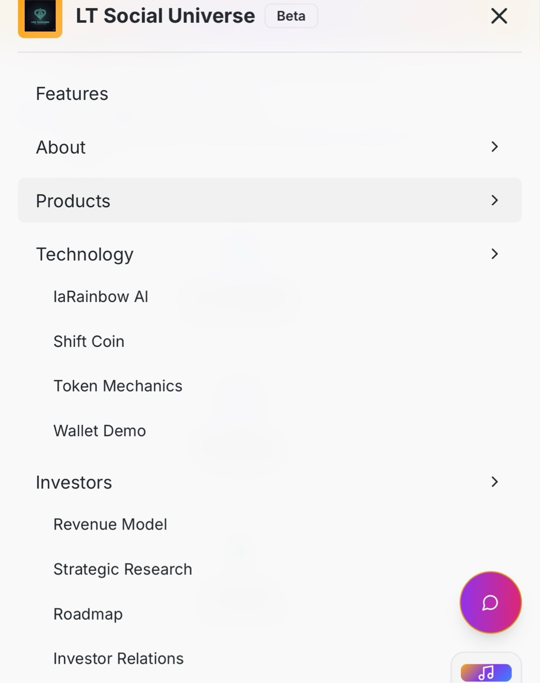
8A39DD19-C350-407F-BD82-B51AE7EEA154.jpeg
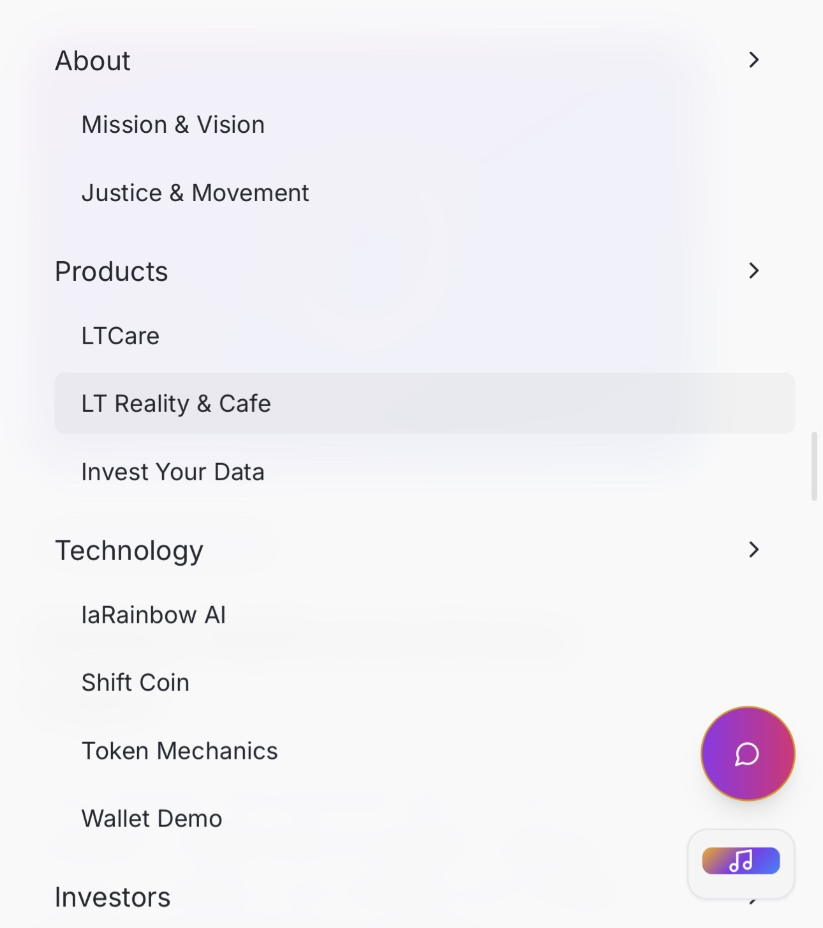
Cap.png
