V1 LTSocial Guild Report
LTSocial Guild Report (Mainstream, App Store Compliant)
Mining Miracles Everyday - Connect. Plan. Stream. Earn. Stay Safe.

V1 | Generated: 2026-01-31 | Domains: lovetranscendsreality.org and LTSocial.net

1. Executive Summary
This report defines a cohesive product, business model, technical scope, and 10-year financial baseline for the Love Transcends ecosystem (LTSocial.net and lovetranscendsreality.org). Each version is designed to be independently shippable, with clear guardrails around app-store compliance and realistic operating costs.

2. Version Definition
V1 is the mainstream, app-store-friendly core: Marketplace + Streaming + Paid Content (PPV and weekly subscriptions) with strong safety defaults. It intentionally avoids regulated cash-out and real-money token conversion inside the mobile apps to minimize compliance risk.

3. Scope Matrix (What Ships in This Version)
Feature | V1
Marketplace (digital goods: photos, videos, AI music, NFTs/collectibles) | ✅
Live streaming (native) + Twitch connect | ✅
Tips + one-time pay-per-view posts | ✅
Weekly subscription to creators (Fanship) | ✅
Friendship feed (invite-only via Friendship Code) | ✅
Hidden view counter for creator only | ✅
Messaging (friendship-only, optionally paid fan inbox in later versions) | ✅
Sponsor Boost (paid amplification for posts/events) | ✅
Calendar + Events + Tickets (Apple/Google calendar integration) | —
Location safety (temporary share, check-ins, event map) | —
AI Guardian safety + moderation | ✅
Therapist layer / 4Family Plus (regulated) | —
Reality Coin (RC) wallet + top-ups + spending | —
VPN-based mining network (verified mining) | —
Cash-out (2x/month, max $1,000; crypto wallet transfer) | —
Post minting (on-chain proofs; NFT-style ownership) | —
Multi-network proofs (fast chain + second chain proofs) | —
Decentralized DNS / naming (human-readable IDs, wallet handles) | —
Node licensing / enterprise services | —
Legend: ✅ included in this version; — not included or deferred.

4. Positioning: Tech-First, Safety-First Social Commerce
The mainstream differentiator is not 'another social feed'. It is a tech-first social commerce system with three pillars: (1) creator monetization that is easy to understand, (2) safety controls that are visible and default-on, and (3) modular permissions so users can share differently across audiences.
Key promises (user-facing):
- Earn through your content: tips, one-time paid unlocks, and weekly subscriptions.
- Sell digital goods instantly: AI-created music, photos, videos, and collectible-style items.
- Friendship Code makes the private 'friendship layer' opt-in and spam-resistant.
- Creators see metrics; viewers do not get pressured by public counters.
- Safety guardrails: report/block, comment limits, and optional AI Guardian filters.

5. Product Experience Model

5.1 Feeds and Visibility
LT Social uses a simple two-layer feed model in the mainstream build (plus optional public discovery where allowed):
- Fanship Feed: paid content surface for streamers and creators (PPV posts, weekly subs, subscriber-only drops).
- Friendship Feed: invite-only via Friendship Code; designed for real-life circles; posting is non-paywalled by default.
- Optional Public/Explore: discovery surface with strict safety filters and no private messaging access by default.

5.2 Hidden Creator View Counter
Each post tracks a view counter visible only to the original poster (creator) and platform admins. Viewers do not see view counts, to reduce social pressure and manipulation. The creator dashboard includes: unique viewers, repeat viewers, unlock conversions, refunds/chargebacks, and retention.

5.3 Messaging Rules
Messaging is friendship-gated: users can only DM if they have exchanged Friendship Codes (or are in the same approved inner circle/group). This reduces spam and makes the platform safer by default.

6. Marketplace and Creator Profiles

6.1 Digital Marketplace (Core)
The Marketplace sells digital goods only in early stages to keep operational risk low (no shipping, no chargeback disputes about physical delivery).
- Digital listings: AI music tracks, AI photos, AI videos, templates, presets, short clips, and collectible-style items.
- Optional 'collectible' mode: a limited quantity listing with a certificate of authenticity (V1) or on-chain minting (V2/V3).
- Royalty-friendly design: creators can set a resale royalty for collectible-style items in V2/V3.
- Refund policy: digital purchases are final by default; limited refunds only for platform errors (policy must be explicit).

6.2 Payout Split
Marketplace split: creator receives 80% of each sale; platform retains 20% for operations, moderation, storage/bandwidth, and payment processing buffers.

6.3 Creator Profiles
Creator profiles unify streaming + store + paid posts. The profile includes: storefront, subscription options, PPV catalog, stream schedule, and verified badges.
- Upload tools: bulk upload, pricing, metadata, content rating (family-safe / mature), and license terms.
- Live streaming: go live, schedule streams, replays, clips, and tip goals.
- Analytics: revenue, conversion funnels, buyer cohorts, and audience retention.
- Privacy: viewer identity can be anonymous to creators for purchases (buyers appear as 'Anonymous Buyer' unless they opt in).

7. Monetization and Transaction Rules

7.1 Paid Content Options
- One-time unlock (PPV): viewer pays once to unlock a post or replay.
- Weekly subscription: viewer pays a recurring weekly fee set by the creator.
- Tips: one-time support payments during streams or on posts.
- Friendship repost license: reposting content into Friendship Feed can require a $5 license paid directly to the original creator wallet (anti-spam + creator support).

7.2 Platform Fees (Baseline)
Standard platform fee on paid content (tips/PPV/subscriptions): 17% of the creator-set price. Marketplace takes 20%.
Beta incentive (optional): for early traction you can run a limited promo where platform fee drops to 5% until either 250 paying users or $1,000,000 of processed volume (whichever comes first).

7.3 Store Policy Reality Check
On iOS and Android, digital goods sold in-app may require Apple/Google in-app purchase systems, which impose platform commissions. To remain compliant, V1 assumes in-app purchases for mobile and a parallel web checkout for desktop where permitted.
Reference fee frameworks: Apple App Store commissions and subscription rules, and Google Play service fees. See References section for official sources.

8. Safety, Moderation, and Compliance
Safety is a first-class product system, not a policy page. The platform must ship with clear user controls, creator tools, and enforcement workflows.
- Age gating and content ratings: family-safe defaults plus mature content tags.
- Report/block/mute with rapid enforcement queues.
- Comment and messaging guardrails (limits, cooldowns, and friendship gating).
- Automated detection for harassment, scams, and child safety risks (with human review escalation).
- Transparent enforcement: warnings, strikes, and appeal flow.

9. Technical Architecture (Buildable)
High-level architecture is designed for modular expansion. Start with a single API and modular services, then split into dedicated services as load grows.

9.1 Core Services
- Web app: Next.js/React (marketing + web app shell).
- Mobile app: React Native or Flutter (thin native shell + modules).
- Backend API: FastAPI (or Node) with modular routers for Feed, Market, Payments, Identity, Safety, and Streaming.
- Data: Postgres for relational data; Redis for caching/rate limiting; object storage (S3-like) for media.
- Search: OpenSearch/Meilisearch for discovery.
- Realtime: WebSockets for chat and live interactions.

9.2 Media and Streaming
- Live streaming: start with a managed service (AWS IVS or similar) to reduce operational complexity.
- Replays and VOD: store in object storage; generate adaptive bitrate ladders.
- Content scanning: virus scan, malware detection, and basic moderation checks on upload.
- Bandwidth controls: per-plan caps and encoding presets.

10. Delivery Roadmap
- 0-30 days: Marketplace MVP (digital goods), creator profiles, PPV unlocks, weekly subs, friendship code + messaging gate.
- 31-60 days: Native streaming MVP (managed service), tips, replays, moderation queues, and payout reporting.
- 61-90 days: Sponsor Boost, improved discovery, creator analytics, and subscription plan ladder.
- 3-6 months: iOS/Android polishing, app store review hardening, scalability work, and creator onboarding pipeline.
- 6-12 months: Events (basic) + optional calendar integration; expand analytics and brand partnerships.

11. 10-Year Financial Baseline (Planning Model)
The financial model below is a baseline planning scenario, not a guarantee. It assumes strong execution, increasing product-market fit, and disciplined cost control. Numbers are in USD and shown as annual totals.

11.1 Key Model Assumptions
- Users grow from 250,000 to 25,000,000 over 10 years (modeled as CAGR).
- Monthly active rate increases from 35% to 45% as retention improves.
- Paying plan adoption increases from 2.0% to 3.5% of users.
- Marketplace take rate: 20% (creator keeps 80%).
- Paid content take rate: 17% (platform fee on PPV/tips/subs).
- Payment processing reserve: ~3.5% blended (processing + disputes buffer).
- Cloud/infra modeled as % of revenue, declining with scale (from 18% to 8%).
- Headcount grows from 10 to 60 over 10 years; loaded cost per FTE: $185,000/year.

11.2 Baseline 10-Year P&L Snapshot
Year | Users | Total_gross_rev | Total_cost | EBITDA | EBITDA_margin
2026 | 250000 | $5.1M | $5.0M | $0.1M | 1.7%
2027 | 417025 | $9.4M | $7.9M | $1.5M | 16.0%
2028 | 695640 | $17.3M | $12.9M | $4.4M | 25.2%
2029 | 1160397 | $31.9M | $21.6M | $10.3M | 32.2%
2030 | 1935659 | $58.8M | $37.1M | $21.8M | 37.0%
2031 | 3228874 | $108.6M | $64.6M | $44.0M | 40.5%
2032 | 5386087 | $200.5M | $114.0M | $86.5M | 43.2%
2033 | 8984534 | $370.6M | $203.0M | $167.6M | 45.2%
2034 | 14987106 | $685.3M | $364.3M | $321.0M | 46.8%
2035 | 25000000 | $1,268.0M | $657.2M | $610.8M | 48.2%

11.3 Charts
Financial trajectory (revenue, cost, EBITDA):
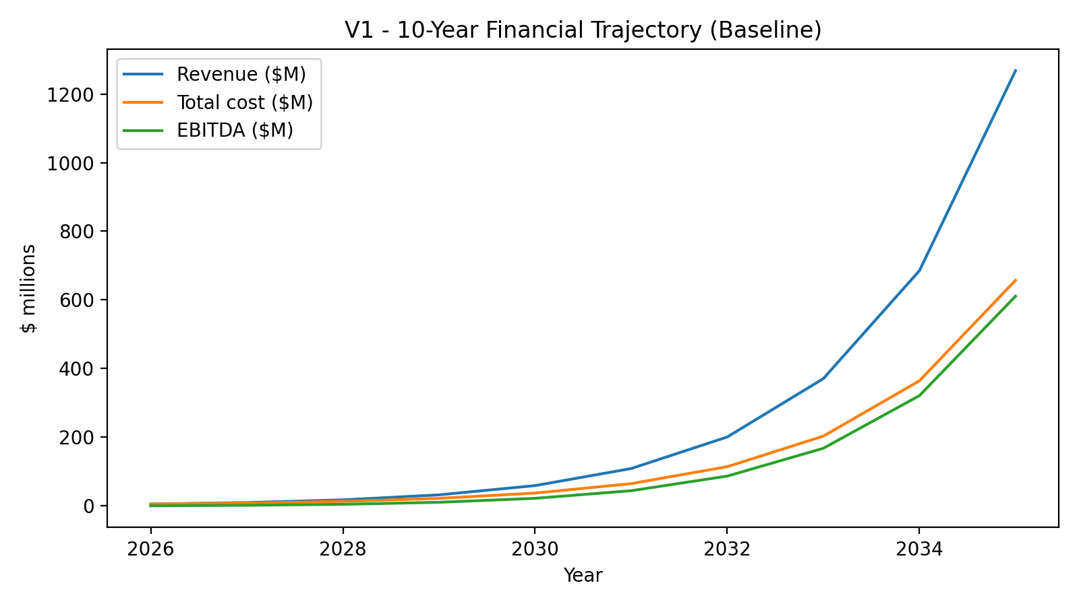
User growth (total users and MAU):
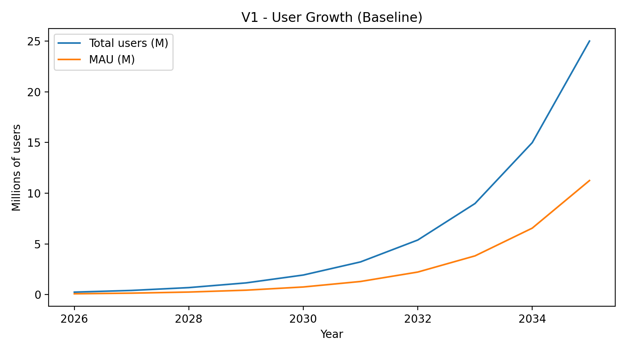

12. Cost Model (What It Takes to Run This)
Costs are modeled as a blend of headcount, infrastructure, and operating overhead. The biggest drivers are moderation/safety (human + tooling) and streaming bandwidth.

12.1 Headcount Plan
Year 1 staffing begins around 10 FTE and scales to ~60 FTE by Year 10 in the baseline. Teams include: Product, Design, Web, Mobile, Backend, DevOps/SRE, Security, Trust & Safety, Data/Analytics, Customer Support, and Partnerships.

12.2 Infrastructure Drivers
- Streaming costs scale with viewer-hours (encoding + delivery).
- Media storage grows with replays, VOD libraries, and marketplace inventory.
- Safety tooling: automated scanning, rate limiting, and logging.
- Search and recommendation systems scale with content volume.

13. Risks and Mitigations
- App store policy risk: design payments and digital goods flows to remain compliant; keep conversion web-first.
- Trust & Safety scale: budget for moderation early; use strict defaults (friendship gating, rate limits).
- Fraud/chargebacks: implement risk scoring, velocity limits, and manual review for payouts.
- Creator quality: build onboarding, verification, and anti-copyright infringement controls.
- Regulatory risk (V2/V3): obtain qualified legal counsel for money services, stable-value claims, and therapy features.

14. References (Official Sources)
- Apple - App Store Small Business Program and commission framework: https://developer.apple.com/app-store/small-business-program/
- Apple - subscriptions and commission after one year (overview): https://developer.apple.com/app-store/subscriptions/
- Google Play - Service fee information: https://support.google.com/googleplay/android-developer/answer/112622?hl=en
- Stripe - pricing: https://stripe.com/pricing
- AWS IVS - pricing (managed live streaming): https://aws.amazon.com/ivs/pricing/

